Dissertation Title

Cell-Level Antimicrobial Susceptibility Prediction Using Segmentation-Driven Deep Learning Models

Final Thesis

In Partial Fulfillment
of the Requirements for the Degree of
Master in Computer Science

Student Name | : | Akhil Akula
Student ID | : | 2959567
Supervisor | : | Md Atiqur Rahman Ahad

Abstract
Antimicrobial resistance is becoming a serious global problem, and fast identification of drug effectiveness is very important in microbiology. In this study, we present a segmentation-driven deep learning approach for predicting antimicrobial susceptibility at cell level. The proposed method uses microscopic images of bacterial cells treated with different antibiotics such as ciprofloxacin, gentamicin, rifampicin, and control samples. First, the raw multi-channel TIFF images are preprocessed and normalized, and then cell segmentation is performed using adaptive thresholding and watershed-based techniques. This step helps in isolating individual bacterial cells, which is important because whole-image analysis may reduce the model accuracy sometimes.
After segmentation, individual cell images are extracted and resized into fixed dimensions, creating a refined dataset for training. The dataset is then divided into training, validation, and testing sets. To handle class imbalance problem, class weights are applied during training process. Multiple deep learning models including a custom Convolutional Neural Network (CNN), DenseNet169, and Vision Transformer are trained and evaluated on the segmented dataset. These models learns discriminative features from cell morphology and fluorescence patterns, which is useful for identifying antibiotic response.
The experimental results shows that segmentation-based approach improves classification performance compared to non-segmented inputs. Among all models, transfer learning based DenseNet169 achieved the best performance with an accuracy of 73.21%, precision of 81.40%, recall of 61.62%, and F1-score of 72.21%, along with the lowest loss value of 0.6899. The CNN model achieved an accuracy of 61.99% and an F1-score of 60.50%, but showed a higher ROC-AUC value of 0.84, indicating good ranking capability. In contrast, the Vision Transformer performed poorly with an accuracy of 37.68%, recall of only 0.95%, and F1-score of 33.97%, showing difficulty in learning from the given dataset. Confusion matrix analysis further confirms that DenseNet169 provides more balanced and accurate predictions across all classes compared to other models.
Overall, this study demonstrates that combining image segmentation with deep learning can provide an effective solution for cell-level antimicrobial susceptibility prediction. This method can support automated and faster decision making in clinical microbiology, but further improvements is needed for real-world deployment.

Keywords: Cell Segmentation, Antimicrobial Susceptibility, Deep Learning, DenseNet169, Vision Transformer, Medical Image Analysis
Acknowledgements

I would like to express my sincere gratitude to my supervisor, Md Atiqur Rahman Ahad, at the University of East London, for his continuous guidance, support, and valuable feedback throughout the development of this project. His expertise, encouragement, and constructive suggestions played a vital role in shaping the direction and successful completion of this research.

I am also thankful to the faculty and staff of the University of East London for providing the necessary academic resources and learning environment that supported this study. Their contribution has been instrumental in enhancing my knowledge and research skills.

Finally, I would like to extend my heartfelt appreciation to my family and friends for their constant encouragement, motivation, and support during the course of this project. Their belief in me has been a source of strength and inspiration.
Table of Contents
Abstract ii
List of Tables vi
List of Figures vii
List of Acronyms ix
Chapter 1 Introduction 1
1.1 Background 1
1.2 Problem Statement 2
1.3 Research Question and Objectives 3
1.4 Expected Outcomes 4
Chapter 2 Literature Review 5
2.1 Survey 5
2.2 Critical Analysis 11
Chapter 3 Methodology 14
3.1. Data Acquisition 14
3.2. Data Preprocessing 15
3.3. Data Splitting 15
3.4. Cell Segmentation 16
3.5. Cell Extraction and Transformation 16
3.6. Feature Extraction 17
3.7. Class Imbalance Handling 17
3.8. Model Development 17
3.8.1 CNN Model 17
3.8.2 DenseNet169 17
3.8.3 Vision Transformers 17
3.9. Performance Evaluation 18
3.10. Best Model Selection 18
Chapter 4 Implementation 19
4.1 System Architecture 19
4.2 Data Collection 19
4.3 Data Preprocessing 21
4.4 Segmentation & Feature Extraction 22
4.5 Feature Selection & Data Preparation 24
4.6 Model Development 26
4.7 Performance Evaluation 31
4.8 Test Predictions 32
Chapter 5 Result Analysis 34
5.1 Experimental Setup 34
5.2 Dataset Description 36
5.3 CNN Model 37
5.3.1 Metrics 37
5.3.2 Accuracy & Loss Curves Analysis 38
5.3.3 Confusion Matrix 39
5.3.4 ROC-AUC Analysis 40
5.4 DenseNet Model 40
5.4.1 Metrics 40
5.4.2 Accuracy & Loss Analysis 41
5.4.3 Confusion Matrix 42
5.4.4 ROC-AUC Analysis 42
5.5 Vision Transformers Model 43
5.5.1 Metrics 43
5.5.2 Accuracy & Loss Analysis 44
5.5.3 Confusion Matrix 45
5.5.4 ROC-AUC Analysis 45
5.6 Comparison 46
5.6.1 Accuracy Comparison 46
5.6.2 Precision Comparison 47
5.6.3 Recall Comparison 48
5.6.4 F1 Score 49
5.7 Overall Comparison 50
Chapter 6 Conclusion 51
6.1 Conclusion 51
6.2 Future Enhancement 51
References 53
Appendix 57
A.1 Code 57

List of Tables
Table 1. Summary of Literature Survey 11
Table 2. Comparison Table 12
Table 3. Metrics for CNN 38
Table 3. Metrics for DenseNet 40
Table 3. Metrics for ViT 43

List of Figures
Figure 1. Architecture Diagram 14
Figure 2. Sample Images from Dataset 15
Figure 3. Dataset Downloading 20
Figure 4. Zip file Extraction 20
Figure 5. Organization Dataset Folder 20
Figure 6. Information about tiff image 22
Figure 7. Segmentation Function 24
Figure 8. Train Test Validation Split 25
Figure 9. Class Balancing Code 26
Figure 10. CNN Model Code 27
Figure 11. CNN Compilation 28
Figure 12. CNN Model Training 28
Figure 13. DenseNet169 Model Code 28
Figure 14. DenseNet Compilation 29
Figure 15. DenseNet Training 29
Figure 16. Vision Transformers Model Code 30
Figure 17. ViT Compilation & Summary 30
Figure 18. ViT Training 31
Figure 19. Calculating Evaluation Metrics 31
Figure 20. Plotting ROC-AUC Curves for all models 32
Figure 21. Test Predictions using Best Model 33
Figure 22. Sample Data 36
Figure 23. Accuracy and Loss Plot of CNN Model 39
Figure 24. Confusion Matrix of DenseNet 39
Figure 25. ROC-ACU of CNN 40
Figure 26. Accuracy & Loss Plot of DenseNet169 Model 42
Figure 27. Confusion Matrix of CNN 42
Figure 28. ROC-AUC of DenseNet 43
Figure 29. Accuracy & Loss Plot of ViT Model 44
Figure 30. Confusion Matrix of ViT 45
Figure 31. ROC-AUC of ViT 46
Figure 32. Accuracy Comparison 46
Figure 33. Precision Comparison 47
Figure 34. Recall Comparison 48
Figure 35. F1 Score Comparison 49

List of Acronyms
TIFF Tagged Image File Format
CIP Ciprofloxacin
GENT Gentamicin
RIF Rifampicin
WT Wild Type
CNN Convolutional Neural Networks
ROC-AUC Receiver Operating Characteristics – Area Under Curve

Chapter 1 Introduction
Antimicrobial resistance has become a serious global problem, affecting both healthcare systems and patient outcomes. Traditional methods for testing antimicrobial susceptibility are often time-consuming and require manual observation, which can lead to delays in treatment decision. Because of this, there is a growing need for automated and faster approaches that can give reliable results in less time. Recent advancements in deep learning and computer vision have shown promising results in medical image analysis, specially at microscopic level.

In this study, a segmentation-driven deep learning approach is used to predict antimicrobial susceptibility at the cell level. The main idea is to first isolate individual bacterial cells from microscopy images and then use these segmented cells for classification. This process helps the model to focus only on relevant regions instead of learning from entire images which may contain noise or unnecessary background. However, segmentation itself is a challenging task, as cells may overlap, vary in shape, and sometimes not clearly visible.

The dataset used in this work consists of multi-channel TIFF images representing different antibiotic conditions such as wild type and treated samples. Preprocessing steps like normalization, resizing, and augmentation are applied to improve model performance. After segmentation, multiple deep learning models including Convolutional Neural Networks, transfer learning models, and Vision Transformers are trained and evaluated. Each model tries to capture different patterns from the segmented cell images, but their performance can vary depend on architecture and training strategy.

Overall, this research aims to improve the efficiency and accuracy of antimicrobial susceptibility prediction. Even though the results are promising, there are still limitations in generalization and dataset variability which need further improvement in future works.

1.1 Background
Antimicrobial resistance is becoming a serious problem in healthcare, where bacteria are not responding to drugs properly. Traditional methods for testing antimicrobial susceptibility usually take long time and need manual observation under microscope. This process is slow and sometimes inconsistent, because it depend on human expertise. In many labs, large number of microscopy images are generated, but analyzing them manually is difficult and time consuming. So there is a need for automated system which can quickly and accurately predict how bacteria respond to different antibiotics.

In this work, the problem is focused on predicting antimicrobial susceptibility at cell level using microscopic images. The dataset contains images of bacterial cells treated with different antibiotics like CIP, GENT, RIF and WT. But the main challenge is that raw images contains multiple cells and background noise, so directly applying deep learning models may not give good results. Also, there is variation in cell shapes and sizes, which makes classification more complex. Another issue is class imbalance, where some classes have more samples than others, which can affect model performance.

To solve this problem, segmentation is used as an important step to extract individual cells from the images. By isolating each cell, the model can focus on meaningful features instead of irrelevant background. After segmentation, deep learning models like CNN, DenseNet and Vision Transformer are applied to classify the cells. This approach tries to improve accuracy and make the system more robust.

The motivation behind this work is to reduce human effort and speed up the diagnostic process. If we can predict antimicrobial susceptibility automatically, it can help doctors to take faster decisions and give correct treatment. Also, using deep learning with segmentation gives better understanding of cell level patterns, which is not easy to see manually. This study aims to show that combining image processing and deep learning can provide efficient and scalable solution, even though there are some challenges in data quality and preprocessing.

1.2 Problem Statement
The increasing problem of antimicrobial resistance is becoming a serious challenge in healthcare systems, but still many traditional methods for testing bacterial response to antibiotics are slow and require manual effort. In many laboratories, the process of identifying whether a bacteria is resistant or sensitive to a drug is done using culture based techniques, which takes long time and also depends on human observation. This creates delays in treatment decisions and sometimes leads to wrong selection of antibiotics, which is not good for patient outcomes (World Health Organization, 2020).

In this project, the main problem is to develop an automated and accurate system that can predict antimicrobial susceptibility at cell level using microscopic images. The dataset contains multi-channel tif images of bacterial cells treated with different antibiotics, but these images are complex and not directly usable for classification. So first, segmentation of individual cells is required, which itself is a difficult task because cells may overlap, have different shapes, or low contrast regions. If segmentation is not done properly, then model performance will be affected badly (Ronneberger et al., 2015).

Another issue is that deep learning models need large and balanced datasets, but here class imbalance is present which can bias the model toward majority classes. Also, different models like CNN, DenseNet and Vision Transformer may behave differently on such biological data, so selecting the best model is also a challenge. It is important to compare them properly using metrics like accuracy, precision, recall and F1-score, but sometimes high accuracy does not mean good real performance (He et al., 2016).

Therefore, the problem is to design a segmentation-driven deep learning pipeline that can correctly extract cells and classify them into antibiotic categories with high reliability, even when data is limited and noisy. This system should reduce manual work and give faster predictions, but achieving this is not easy and needs careful design and evaluation (Dosovitskiy et al., 2021).

1.3 Research Question and Objectives
Research Question
- How effectively segmentation based methods can isolate individual bacterial cells from microscopy images for further analysis?
- Does using segmentation driven approach improve the accuracy of antimicrobial susceptibility prediction or not?
- Which deep learning model (CNN, DenseNet169, Vision Transformer) perform better for cell-level classification tasks?
- How class imbalance in segmented dataset is affecting the model performance and prediction results?
- Can extracted cell features from Nile Red channel give enough information to classify different antibiotic responses?
- What are the limitations of current segmentation techniques when dealing with overlapping or noisy cells images?

Objectives
- To develop a segmentation pipeline that can accurately detect and extract individual bacterial cells from raw microscopy images.
- To preprocess and normalize multi-channel TIFF images for improving model learning process.
- To build and train multiple deep learning models like CNN, DenseNet169, and Vision Transformer for classification.
- To compare performance of different models using metrics like accuracy, precision, recall and F1-score.
- To handle class imbalance problem using techniques like data augmentation and class weights for better results.
- To evaluate the effectiveness of segmentation driven learning approach for antimicrobial susceptibility prediction at cell level.

1.4 Expected Outcomes
The expected outcomes of this research is to develop an accurate and reliable system for predicting antimicrobial susceptibility at cell level using deep learning models. The study will show that segmentation of individual cells can improve the classification performance, because model is able to focus more on important cell features rather than background noise. It is also expected that the preprocessing steps like normalization and augmentation helps to increase the robustness of model, even when data is slightly imbalanced.

Another outcome is comparison between different models such as CNN, DenseNet169 and Vision Transformer, where one model will perform better in terms of accuracy, precision and F1-score. The results may indicate that transfer learning based model gives better generalization, but sometimes simple CNN also perform competitively. The segmentation approach also expected to increase number of training samples by extracting multiple cells from single image, which improve learning capacity of models.

Finally, the system can be useful for biomedical applications, where fast and automated prediction is required. It may reduce manual effort and also give consistent results, but still some limitations can be present like dependency on segmentation quality. Overall, this research will contribute towards intelligent healthcare solutions and provide a base for future improvements.

Chapter 2 Literature Review

2.1 Survey
Deep Learning for Antimicrobial Susceptibility Testing (AST)
Recent research in deep learning has shown strong potential in antimicrobial susceptibility testing and resistance prediction, especially when applied to biological image analysis. One important study focused on analyzing single-cell morphological changes in Escherichia coli, where deep learning models were used to distinguish between treated and untreated cells. This approach achieved around 80% accuracy across multiple antibiotics and demonstrated that meaningful biological insights can be obtained much faster than traditional growth-based methods. The ability to generate results within a short time, around 30 minutes, shows that such systems can be very useful in real-world clinical scenarios, although the model performance still depends on quality of data and segmentation accuracy (Zagajewski et al., 2023). Another related work introduced the DeepBacs platform, which provides a flexible framework for bacterial image analysis tasks such as segmentation, classification, and phenotypic profiling. This platform uses deep learning models along with accessible tools, making it easier for researchers without strong programming background to apply advanced techniques, but sometimes the results may vary depending on dataset conditions (Spahn et al., 2022).

Explainable AI in Antibiotic Discovery

Further advancements have been made in explainable artificial intelligence for antibiotic discovery. Researchers explored how deep learning models can not only predict outcomes but also provide interpretation about how new antibiotic structures are discovered. This is important because many deep learning models are often seen as black boxes, and lack of explainability can limit their adoption in medical field. The work showed that explainable models can help in identifying new structural classes of antibiotics, which is critical for addressing antimicrobial resistance, though challenges still remain in ensuring model transparency and reliability (Wong et al., 2023). A broader review on artificial intelligence in antimicrobial resistance prediction discussed various machine learning techniques used for gene identification, mutation detection, and drug discovery. The review pointed out that while there is rapid progress in this area, most applications are still in early stages and not fully integrated into clinical practice, which shows that more research and validation is needed (Ali et al., 2023).

Single-Cell Analysis and Cellular Heterogeneity

Machine learning approaches are also playing an important role in drug discovery and precision medicine. At the single-cell level, these techniques allow researchers to study how individual cells respond differently to drugs, which is important because not all cells behave same way under treatment. This concept of cellular heterogeneity is especially relevant in diseases like cancer, where resistant subpopulations can lead to treatment failure. Studies have shown that deep learning models can capture such variations effectively, although training such models requires large and high-quality datasets (Ren Qi & Quan Zou, 2023). Similarly, BacDrop technology demonstrated how single-cell RNA sequencing can reveal differences in bacterial response to antibiotics. It was observed that certain subpopulations exhibit unique transcriptional patterns that are not visible in bulk analysis, which highlights the importance of single-cell level investigation, even if the experimental setup is complex (Peijun Ma et al., 2023).

Machine Learning in Genomic-Based AMR Prediction

In the area of antimicrobial resistance prediction, machine learning models are widely used to analyze genomic data of pathogens. These models attempt to predict resistance patterns based on genetic mutations and features, which can help in early diagnosis and treatment planning. However, one major limitation is that these models often struggle with new or unseen mutations, and their predictions may not always be reliable. Additionally, lack of interpretability can make it difficult for clinicians to trust these systems fully, even though they show promising results in research settings (Jee In Kim et al., 2022). Deep learning is also transforming image-based phenotypic drug discovery, where large datasets of cellular images are analyzed automatically to identify potential drug candidates. This approach reduces manual effort and speeds up the screening process, but it also requires careful validation to ensure that identified patterns are biologically meaningful (Daniel Krentzel et al., 2023).

Antimicrobial Peptides and Drug Discovery using AI

Recent developments in deep learning have also contributed to antimicrobial peptide prediction, which is an emerging area in drug discovery. Computational models are now able to identify potential peptide candidates that can act as effective antimicrobial agents. These models provide new opportunities for designing novel therapies, especially in cases where traditional antibiotics fail. However, challenges such as dataset imbalance and lack of experimental validation still limit their widespread application (Zhou et al., 2025). Another comprehensive study examined different deep learning frameworks used in antibiotic discovery, including both discriminative and generative models. While these models show great promise, the study highlighted issues like limited data availability and the need for better evaluation methods, which indicates that current systems are still under development (Cesaro et al., 2023).

Transfer Learning and Rapid Susceptibility Testing

Transfer learning has also been applied to improve antimicrobial resistance prediction, especially when datasets are small or imbalanced. By leveraging knowledge from pre-trained models, researchers were able to improve prediction performance for new antibiotics. This approach helps in overcoming data limitations, although it may introduce bias if the source and target datasets are not well aligned (Ren et al., 2022). In another practical application, convolutional neural networks were used to analyze scattered-light images for rapid susceptibility testing. The results showed that accurate predictions can be made within two hours, which is significantly faster than traditional methods, but implementation in clinical settings may require further validation (Graf et al., 2024).

Imaging Techniques and Synthetic Data Generation

Advances in imaging technologies combined with machine learning are also improving bacterial analysis. High-content imaging methods have been used to predict antibiotic susceptibility without exposing bacteria to antibiotics. By analyzing morphological features, models can classify samples based on susceptibility patterns, which reduces the need for direct drug testing. However, this approach depends heavily on imaging quality and feature extraction methods (Tran et al., 2024). To address limitations in training data, synthetic data generation techniques have been introduced. For example, SyMBac generates artificial bacterial images that can be used to train segmentation models. These synthetic datasets sometimes outperform manually annotated data, although there may be concerns regarding how well they represent real-world scenarios (Hardo et al., 2022).

Segmentation Benchmarks and Microfluidics Applications

Benchmark datasets and evaluation frameworks have also been developed to improve cell segmentation performance. A large-scale benchmark study provided labeled datasets across multiple imaging modalities, enabling fair comparison of different models. Transformer-based approaches achieved strong performance in these benchmarks, showing their ability to generalize across diverse conditions, even if they require high computational resources (Ma et al., 2023). In clinical applications, microfluidic techniques have been used for rapid susceptibility testing and species identification at single-cell level. These methods can process multiple samples simultaneously and provide results within a short time, but integration with machine learning systems is still ongoing (Kandavalli et al., 2022).

Multi-Modal Learning and Biological Data Integration

Deep learning has also improved cell segmentation and biological analysis through integration of multiple data types. For example, combining gene expression data with imaging data has been shown to improve segmentation accuracy. Recursive training strategies help in handling noisy labels, which is a common issue in biological datasets. However, such methods can be computationally intensive and require careful tuning (Wang et al., 2023). In antimicrobial resistance detection, convolutional neural networks have been applied to genomic data, achieving high accuracy in predicting resistance in Mycobacterium tuberculosis. These models also identified new resistance-associated regions, which can contribute to better understanding of disease mechanisms, even though further biological validation is required (Green et al., 2022).

Automated Cell Analysis and Experimental Integration

Other studies have explored automated analysis of drug-treated cells using deep learning models. High accuracy has been achieved in classifying different cell states, such as normal, diseased, and treated conditions. This shows that deep learning can effectively capture subtle differences in cellular morphology, although performance may vary across datasets (Nawabi et al., 2022). Additionally, integration of deep learning with experimental techniques like cell-free protein synthesis has accelerated antimicrobial peptide discovery. This approach allows rapid screening of thousands of candidates, leading to identification of effective peptides, including some with broad-spectrum activity, though scalability remains a challenge (Pandi et al., 2022).

Clinical Applications and Personalized Medicine

Machine learning is also being used to improve antibiotic usage in clinical practice. Personalized antibiograms have been developed using patient data to predict susceptibility patterns, which helps in selecting appropriate antibiotics and reducing unnecessary use of broad-spectrum drugs. While these systems show good coverage rates, their effectiveness depends on quality and completeness of health records (Corbin et al., 2022). In peptide research, transfer learning approaches have been used to predict properties like toxicity, improving over traditional methods. These approaches are useful when data is limited, but they may not generalize well to all types of peptides (Salem et al., 2022).

Challenges, Validation and Real-World Constraints

Comprehensive reviews have highlighted the growing role of artificial intelligence in antimicrobial peptide design. Machine learning models can accelerate development and address issues like toxicity and stability, which are major challenges in traditional drug discovery. However, the transition from computational predictions to real-world applications still requires significant experimental validation (Wan et al., 2024). Another study emphasized the importance of using physiologically relevant conditions in susceptibility testing. It was found that test conditions can significantly affect results, and more realistic environments can improve prediction of clinical outcomes, even though such setups are more complex (Heithoff et al., 2023).

Tools, Platforms and Open-Source Frameworks

In computational biology, several tools have been developed to support cell analysis using deep learning. Open-source platforms provide capabilities for segmentation, tracking, and analysis of cell cycles, making advanced techniques more accessible to researchers. These tools reduce the need for programming expertise, but they may still require understanding of underlying concepts for proper usage (Padovani et al., 2022). Similarly, pre-trained models for nucleus segmentation have shown strong performance across different datasets, demonstrating the effectiveness of deep learning in handling complex biological images (Lee et al., 2022).

Emerging Technologies and Advanced Frameworks

Emerging technologies like droplet microfluidics are also contributing to antimicrobial resistance research. These systems allow high-throughput analysis of bacterial populations and can reveal variations in resistance levels within same population. Such insights are important for understanding resistance mechanisms, although integration with computational models is still developing (Postek & Garstecki, 2022). In cancer research, transfer learning frameworks have been used to predict drug responses at single-cell level by combining bulk and single-cell data. This approach helps in studying tumor heterogeneity and resistance, but requires large datasets and computational resources (Chen et al., 2022).

Multitask Learning and Future Scope

Recent developments in multitask deep learning frameworks have further improved efficiency in biological image analysis. Models can now perform multiple tasks such as segmentation, classification, and scoring in a single step, reducing computational complexity and processing time. These approaches are useful in clinical workflows, although they may be sensitive to variations in input data (Ghahremani et al., 2022). Single-cell RNA sequencing studies have also provided insights into cellular heterogeneity, enabling better understanding of drug responses and resistance mechanisms. These datasets support development of more accurate predictive models, even though data processing can be challenging (Gambardella et al., 2022).

In infectious disease research, convolutional neural networks have been applied to bacterial cytological profiling, allowing rapid identification of antimicrobial mechanisms. This helps in understanding how different drugs affect bacterial cells, which is important for developing new treatments. While these models show strong performance, their generalization to different bacterial species may require further study (Quach et al., 2025). Overall, deep learning and computer vision techniques are transforming cell analysis and antimicrobial resistance research by enabling automated, accurate, and scalable solutions. However, challenges such as data quality, model interpretability, and clinical validation still remain, and addressing these issues will be important for future advancements in this field (Chai et al., 2023).

Table 1. Summary of Literature Survey
Paper (Author, Year) | Method/Approach | Overall Findings | Limitations
Zagajewski et al. (2023) | Deep learning on single-cell morphology | Achieved ~80% accuracy in classifying treated vs untreated cells; faster than traditional assays | Performance depends on segmentation quality; limited generalization across datasets
Spahn et al. (2022) | DeepBacs platform for image analysis | Multi-task learning for segmentation, classification, and phenotyping; user-friendly platform | Results vary with dataset quality; requires proper parameter tuning
Wong et al. (2023) | Explainable deep learning for antibiotic discovery | Identified new structural antibiotic classes; improved interpretability | Still complex; limited real-world validation
Ali et al. (2023) | Review of AI in AMR prediction | Highlighted ML applications in gene detection and drug discovery | Most models in early stage; limited clinical deployment
Ren Qi & Quan Zou (2023) | Single-cell ML analysis | Captured cellular heterogeneity in drug response | Requires large-scale high-quality data; computationally expensive
Peijun Ma et al. (2023) | BacDrop single-cell RNA-seq | Revealed hidden bacterial subpopulations and resistance patterns | Complex experimental setup; high cost
Jee In Kim et al. (2022) | ML on genomic data | Predicted antimicrobial resistance patterns effectively | Poor handling of new mutations; lack of interpretability
Daniel Krentzel et al. (2023) | Image-based phenotypic drug discovery | Automated screening of large compound libraries | Needs validation; possible false positives
Zhou et al. (2025) | Deep learning for AMP prediction | Identified potential antimicrobial peptides | Dataset imbalance; limited experimental proof
Cesaro et al. (2023) | DL frameworks for antibiotic discovery | Covered CNNs and generative models; strong potential | Lack of validation; data scarcity issues
Ren et al. (2022) | Transfer learning for AMR prediction | Improved performance on small datasets | Risk of bias from pre-trained models
Graf et al. (2024) | CNN on scattered-light images | Rapid susceptibility results within 2 hours | Needs clinical validation; limited organism coverage

2.2 Critical Analysis
The existing studies on antimicrobial susceptibility prediction using deep learning shows significant progress, but there are still many challenges present. One important parameter for comparison is the dataset used. Many studies like Zagajewski et al. (2023) and Ma et al. (2023) used well-structured and labeled datasets, which helps in achieving better model performance. However, some works depend on limited or synthetic data such as Hardo et al. (2022), which may not fully represent real biological conditions. In my proposed work, real microscopic images are used along with segmentation to increase number of samples, which gives better diversity, but still dataset imbalance can affect results sometimes.

Another key parameter is the algorithm applied. Different studies used various approaches like convolutional neural networks, transfer learning, and transformer-based models. For example, Graf et al. (2024) used CNN for fast prediction, while Ma et al. (2023) used transformer models for better generalization. Some works like Ren et al. (2022) applied transfer learning to handle small datasets. In my approach, multiple models such as CNN, DenseNet169 and Vision Transformer are used, which allows comparison between architectures, but training multiple models require more computation time and resources.

The accuracy and performance metrics is also an important factor. Many studies reported high accuracy values, sometimes above 80% or even higher in controlled environments. For example, Green et al. (2022) achieved very high AUC values, while Zagajewski et al. (2023) reported around 80% accuracy. However, these results may not always generalize well to real-world scenarios due to differences in dataset distribution. In my system, multiple evaluation metrics such as accuracy, precision, recall, and F1-score are used to provide balanced evaluation, but still overfitting can occur if data is not properly handled.

Another parameter is limitations and practical applicability. Most studies highlight issues like lack of interpretability, dependency on high-quality data, and need for clinical validation. For example, Ali et al. (2023) mentioned that many models are still not deployed in real clinical systems. Similarly, Wong et al. (2023) discussed the challenge of explainability in deep learning models. In my approach, segmentation improves feature extraction, but it also introduce dependency on segmentation quality, which can affect final prediction.

To give a clear overview, the comparison table below summarizes key parameters across selected studies and the proposed system.
Table 2. Comparison Table
Study | Dataset Used | Algorithm | Accuracy/Performance | Limitation
Zagajewski et al. (2023) | Single-cell images | CNN | ~80% accuracy | Limited generalization
Graf et al. (2024) | Scattered-light images | CNN | Fast prediction (~2 hrs) | Needs clinical validation
Ma et al. (2023) | Benchmark dataset | Transformer | High performance | High computation
Ren et al. (2022) | Small datasets | Transfer Learning | Improved accuracy | Bias risk
Hardo et al. (2022) | Synthetic images | DL models | Good segmentation | Not fully realistic
Green et al. (2022) | Genomic data | CNN | High AUC | Needs validation
Ali et al. (2023) | Review data | ML methods | Conceptual | Not practical yet
Wong et al. (2023) | Structural data | Explainable DL | Improved insights | Complexity
My Proposed Work | Segmented cell images | CNN, DenseNet, ViT | Balanced metrics | Segmentation dependency

Overall, it can be observed that while deep learning models provide strong performance, there is still gap between research and real-world application. My proposed system tries to address some of these gaps by combining segmentation with multiple models, but further improvements is still needed for robustness and deployment.

Chapter 3 Methodology
The proposed system for cell-level antimicrobial susceptibility prediction is designed as an end-to-end deep learning pipeline which integrates image processing, segmentation, and classification techniques. The overall architecture consists of multiple sequential components starting from raw data acquisition and ending with final prediction and evaluation. The pipeline is carefully structured so that each stage contributes meaningful transformation of data, although sometimes there is small variations in outputs which may affect downstream steps. The system mainly focuses on transforming microscopy images into meaningful cell-level representations and then learning patterns from them using advanced deep learning models. This pipeline is not only modular but also flexible, so that different models can be plugged into the same workflow with minimal changes.
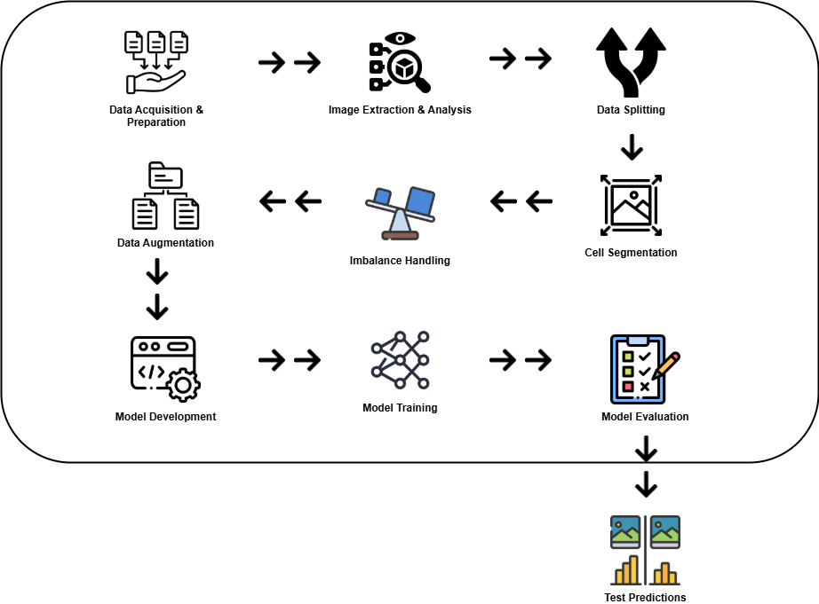
Figure 1. Architecture Diagram

3.1. Data Acquisition
The first stage of the methodology involves data collection. The dataset used in this work is obtained from an openly available biomedical repository which contains microscopy images of bacterial cells treated with different antimicrobial agents. The dataset includes multiple classes such as wild type (WT), ciprofloxacin (CIP), gentamicin (GENT), and rifampicin (RIF). These images are stored in TIFF format, which preserves high-resolution and multi-channel information. Each image consists of three channels, representing different staining or imaging modalities, although not all channels are equally useful for segmentation. The dataset is downloaded programmatically using automated scripts, and then extracted into a structured directory format. It is observed that some folders contain unwanted combinations like COAMOX+ETOH which is removed to maintain consistency in class labels, this step is necessary but sometimes may lead to loss of few samples.
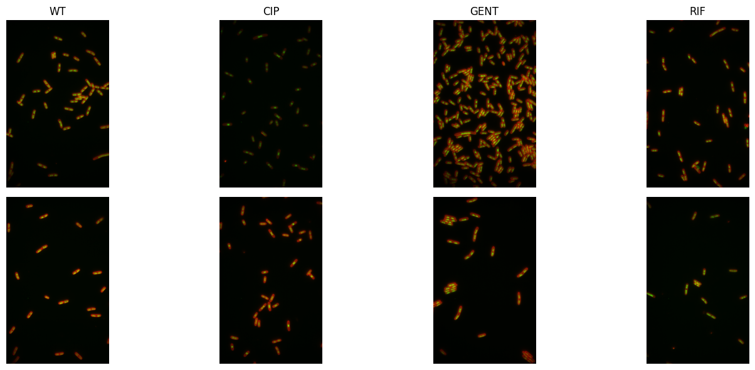
Figure 2. Sample Images from Dataset

3.2. Data Preprocessing
After data collection, preprocessing is performed to prepare the dataset for further analysis. Initially, the directory structure is standardized by renaming folders and ensuring uniform class labels. The images are then inspected to understand their properties such as shape, datatype, and channel distribution. Since TIFF images contain multi-dimensional arrays, they are converted into NumPy arrays for easier manipulation. Normalization is applied to bring pixel values into a consistent range, typically between 0 and 1. This step helps in stabilizing the training process, although sometimes normalization may suppress subtle intensity variations. Additionally, visualization is performed by randomly sampling images from each class, which helps in understanding the visual differences between categories. This manual inspection is important because it gives intuition about the data, but it may not capture all hidden patterns.

3.3. Data Splitting
The dataset is then divided into training, validation, and testing sets using a stratified splitting approach. A ratio of 70:15:15 is used, ensuring that each class is proportionally represented in all subsets. The splitting is done at image level, meaning that individual TIFF images are distributed across splits. The files are physically copied into separate directories corresponding to train, validation, and test sets. This approach ensures reproducibility, but it also increases storage requirements. The splitting process includes random shuffling, so results may slightly vary if repeated multiple times.

3.4. Cell Segmentation
One of the most critical stages in the methodology is segmentation. Instead of directly feeding whole images into the model, the system extracts individual cells from each microscopy image. This segmentation-driven approach improves model performance because it focuses on cell-level features rather than global image characteristics. Initially, channel analysis is performed to identify the most informative channel. It is observed that channel 0 (Nile Red channel) provides the best contrast between cells and background. Therefore, this channel is used for segmentation. The selected channel is normalized and enhanced using techniques such as Contrast Limited Adaptive Histogram Equalization (CLAHE), which improves visibility of cell boundaries. However, sometimes over-enhancement can introduce noise in the image.

Adaptive thresholding is then applied to convert grayscale images into binary masks. This method computes local thresholds for different regions, making it suitable for uneven illumination conditions. Morphological operations such as removal of small objects and filling of holes are applied to refine the binary masks. Border artifacts are also removed to ensure that only complete cells are considered. After obtaining a clean binary mask, a distance transform is computed to identify cell centers. These centers are used as markers in a watershed algorithm, which separates overlapping cells. This segmentation process is quite effective but sometimes it may fail in highly dense regions where cells are touching each other closely.

3.5. Cell Extraction and Transformation
Once segmentation is completed, individual cell regions are extracted using bounding boxes. Each cell is cropped from the original multi-channel image, and a mask is applied to remove background pixels. The cropped cells are then padded to form square images and resized to a fixed dimension (128×128 pixels). This ensures uniform input size for deep learning models. The processed cell images are saved in PNG format, organized by class and dataset split. This transformation significantly increases the number of training samples, but also introduces dependency on segmentation quality.

3.6. Feature Extraction
Following segmentation, feature extraction and selection is implicitly handled by deep learning models. Instead of manually designing features, convolutional neural networks (CNNs) and other architectures automatically learn hierarchical features from the data. However, preprocessing steps such as normalization, resizing, and augmentation play a key role in enhancing feature quality. Data augmentation techniques including rotation, translation, and flipping are applied to the training data. These transformations help in improving model generalization, although excessive augmentation may distort biological structures.

3.7. Class Imbalance Handling
Class imbalance is another important consideration in this methodology. After segmentation, the number of cell images per class may vary significantly. To address this issue, class weights are computed using a balanced weighting scheme. These weights are applied during model training to penalize misclassification of minority classes more heavily. This helps in reducing bias towards majority classes, but sometimes it can make training unstable if imbalance is very high.

3.8. Model Development

3.8.1 CNN Model
The model development stage involves training multiple deep learning architectures to compare their performance. A custom CNN model is designed with multiple convolutional blocks, batch normalization layers, and dropout regularization. The architecture gradually increases the number of filters to capture complex patterns. Fully connected layers are used at the end for classification. This model is relatively lightweight and can be trained from scratch, but it may not achieve very high accuracy compared to pre-trained models.

3.8.2 DenseNet169
In addition to the custom CNN, a transfer learning approach is used with DenseNet169. This model is pre-trained on a large dataset and is capable of extracting rich features. The convolutional base is frozen to retain learned representations, while custom classification layers are added on top. This approach reduces training time and improves performance, although it may not fully adapt to domain-specific features.

3.8.3 Vision Transformers
A Vision Transformer (ViT) model is also implemented to explore attention-based learning. The input images are divided into patches, which are then encoded and processed using transformer layers. Multi-head self-attention allows the model to capture long-range dependencies between different regions of the image. While ViT models are powerful, they require large amounts of data and computational resources, so their performance may vary depending on dataset size.

All models are compiled using categorical cross-entropy loss and optimized using the Adam optimizer. Evaluation metrics include accuracy, precision, recall, and F1-score. Early stopping is used to prevent overfitting by monitoring validation loss. Training is performed for a fixed number of epochs, but the process may stop early if no improvement is observed. Sometimes early stopping may stop too soon before reaching optimal performance.

3.9. Performance Evaluation
Performance evaluation is conducted using multiple metrics to provide a comprehensive analysis. Accuracy measures overall correctness, while precision and recall provide insights into class-specific performance. F1-score is used as the primary metric because it balances precision and recall. ROC-AUC curves are plotted to evaluate model discrimination ability, and confusion matrices are used to visualize classification errors. These evaluation methods provide detailed understanding of model behavior, although interpretation may become complex when dealing with multiple classes.

3.10. Best Model Selection
Finally, the best-performing model is selected based on F1-score and applied to the test dataset. Predictions are generated for unseen cell images, and results are visualized to compare true and predicted labels. This final stage validates the effectiveness of the proposed system. The entire pipeline, from data collection to prediction, forms a complete end-to-end framework for antimicrobial susceptibility prediction. Even though the system performs well, there are still some limitations like dependency on segmentation quality and computational cost of advanced models.

In summary, the methodology presents a structured and comprehensive approach to solving the problem of antimicrobial susceptibility prediction at cell level. Each component of the pipeline plays a important role, and the integration of segmentation with deep learning provides improved performance compared to traditional methods. The system is scalable and can be extended to other biomedical imaging tasks, but further improvements can be made in segmentation accuracy and model optimization.

Chapter 4 Implementation

4.1 System Architecture
The proposed system is designed to perform cell-level antimicrobial susceptibility prediction using a segmentation-driven deep learning approach. The overall architecture consist of multiple stages, starting from raw dataset acquisition to final prediction and evaluation. The system pipeline includes data collection, preprocessing, segmentation, feature preparation, model training, and evaluation.

At the beginning, the raw microscopic images are collected from the publicly available dataset. These images are stored in TIFF format, which contains multi-channel biological information. The system then process these images to extract meaningful cell-level information. The segmentation module plays an important role here, because instead of using whole images, the system isolates individual cells from the background. This makes the model more focused and improve learning efficiency.

After segmentation, each cell is treated as an independent sample. These segmented cells are then passed through preprocessing and augmentation steps. The processed data is fed into different deep learning models such as Convolutional Neural Network (CNN), DenseNet169, and Vision Transformer (ViT). The outputs from these models are compared using multiple evaluation metrics.

The architecture is modular in nature, so each component can be modified or improved independently. This design makes the system flexible and scalable for future improvements.

4.2 Data Collection
The data collection process for this study was carried out using a publicly available biomedical dataset consisting of microscopic cell images. The dataset was obtained from a reliable research repository, which ensures that the data is scientifically valid and suitable for antimicrobial susceptibility analysis. The images mainly contain different bacterial conditions such as untreated (WT) and antibiotic treated samples like CIP, GENT, and RIF. These categories helps in understanding how bacteria responds under different drug exposures, which is important for prediction tasks.
Dataset Downloading
The dataset was downloaded directly using an automated command line approach. This method makes the process more reproducible and efficient for large scale research work. The file was downloaded in compressed format and stored locally for further processing. This step is important because manual downloading can lead to inconsistency sometimes.
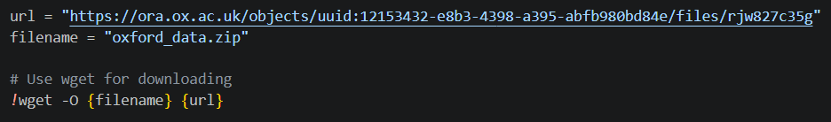
Figure 3. Dataset Downloading
After downloading, a simple check was performed to confirm whether the dataset is properly available or not. This ensures that further steps will not fail due to missing files.
Dataset Extraction
Once the dataset was downloaded, it was extracted using unzip command. The extracted files contains multiple folders corresponding to different experimental conditions. Proper extraction is necessary because sometimes corrupted extraction can lead to data loss or incomplete dataset.
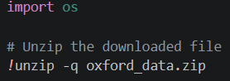
Figure 4. Zip file Extraction
Initial Data Organization & Verification
After extraction, the dataset structure was cleaned and organized. Some folder names were modified to make them simple and easy to use during model training. Also, unwanted folders were removed to avoid confusion in further steps. The number of images in each class was counted to understand the dataset distribution, but it is not always perfectly balanced.
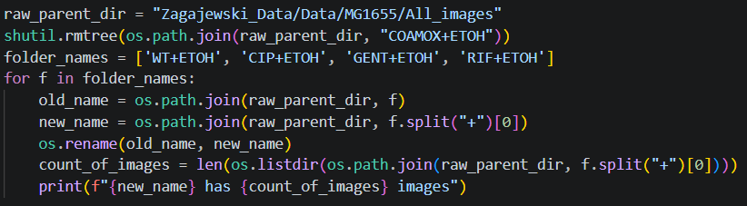
Figure 5. Organization Dataset Folder
In addition to this, sample images were also visualized and basic metadata like shape and datatype was checked. This step gives better understanding of the data, although sometimes image variations are more complex than expected. Overall, the data collection process was systematic but still require careful handling at each stage.

4.3 Data Preprocessing
Data preprocessing is a very important step in this research because the raw microscopic images are not directly suitable for deep learning models. First, the dataset was downloaded from the provided Oxford repository and extracted into local directory. The dataset contains multiple folders representing different antimicrobial conditions such as WT, CIP, GENT, and RIF. Some unwanted folders like COAMOX+ETOH was removed to maintain consistency in class labels. Also, folder names were cleaned by removing suffix “+ETOH” to simplify processing. This step make the dataset more organized and easier to handle.

After organizing the folders, images were explored to understand their structure. Each image was stored in TIFF format and contains multiple channels. These channels represent different fluorescence signals, which are important for identifying bacterial cells. The images were converted into NumPy arrays for further processing. Basic information like shape and datatype was also checked to ensure correct loading of images. This step is useful because sometimes corrupted or incompatible images can create issues during training.

Then, a small number of sample images from each class were visualized. This help in understanding variations between classes and how cells appear under different treatments. The images were normalized using min-max scaling so that pixel values are in a fixed range. This normalization is required because deep learning models perform better when input values are scaled.

Next, the dataset was split into training, validation, and testing sets in the ratio of 70:15:15. This splitting ensures that model is trained on one portion and evaluated on unseen data. Random shuffling was applied before splitting so that distribution of images is balanced across splits. The images were copied into separate directories for each split to make it compatible with Keras data generators.
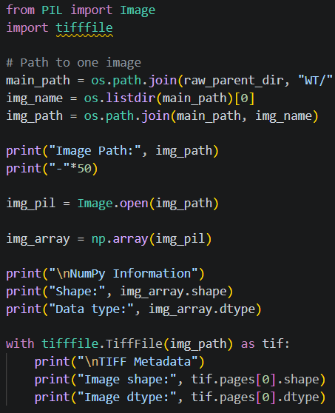
Figure 6. Information about tiff image

4.4 Segmentation & Feature Extraction
Segmentation is one of the most critical part in this research because instead of using full images, individual bacterial cells are extracted. This helps model to focus only on relevant features and not background noise. Initially, different channels of the TIFF images were analyzed. It was observed that channel 0 (Nile Red) clearly highlights the cells, so it was selected for segmentation.

To segment the cells, the selected channel was first normalized into 0–255 range. After that, CLAHE (Contrast Limited Adaptive Histogram Equalization) was applied to enhance contrast. Then Gaussian blur was used to reduce noise in the image. Adaptive thresholding method was used to convert grayscale image into binary mask, where cells appear as white regions and background as black. Some small unwanted regions were removed using morphological operations. Also, objects touching the border were cleared to avoid incomplete cells.

Further, distance transform and watershed algorithm were used to separate overlapping cells. This is very important because cells may be clustered together. The watershed method uses markers to identify individual cell regions. After segmentation, region properties such as area and eccentricity were calculated. Only regions satisfying minimum area and shape conditions were selected. This ensures that only valid cells are extracted.

Each detected cell was cropped from original image using bounding box. Mask was applied so that background pixels become zero. Then, images were padded to square shape and resized to fixed size (128x128). This standardization is necessary for feeding images into deep learning models.
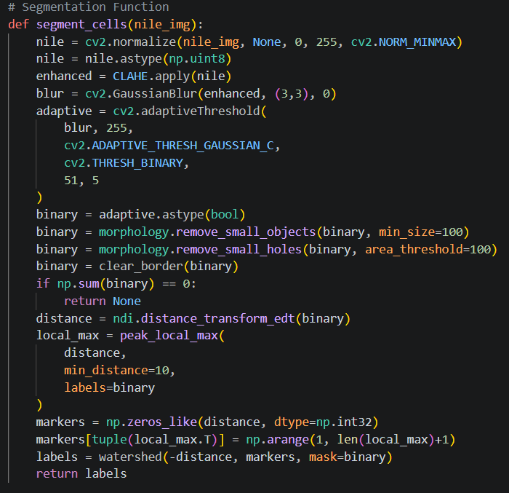
Figure 7. Segmentation Function
Finally, segmented cell images were saved as PNG files. This segmentation-driven approach improve model accuracy because it focus on cell-level information rather than whole image.

4.5 Feature Selection & Data Preparation
After segmentation, the dataset now contains individual cell images instead of full microscopy images. At this stage, feature selection is indirectly handled by deep learning models, but proper data preparation is still very important. First, class distribution was checked to identify imbalance between different antimicrobial categories. It was observed that some classes have more cell images than others, which can bias the model during training.

To handle this issue, class weights were computed using sklearn function. These weights assign more importance to minority classes during training. This helps model to learn equally from all classes. Additionally, data augmentation techniques were applied to increase diversity of training data. Augmentation operations such as rotation, shifting, and flipping were used. These transformations simulate real-world variations and improve generalization capability of the model.
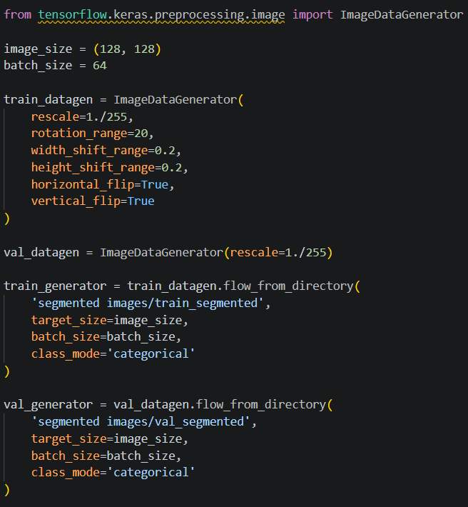
Figure 8. Train Test Validation Split
Images were also rescaled by dividing pixel values by 255 so that they lie between 0 and 1. This normalization improves convergence during training. The dataset was then loaded using ImageDataGenerator, which automatically handles batching and preprocessing during training process.

The input size was fixed to 128x128 pixels, which is suitable for CNN, DenseNet and Vision Transformer models. Also, categorical labels were used since this is a multi-class classification problem. The generators ensure that images are loaded efficiently without consuming too much memory.
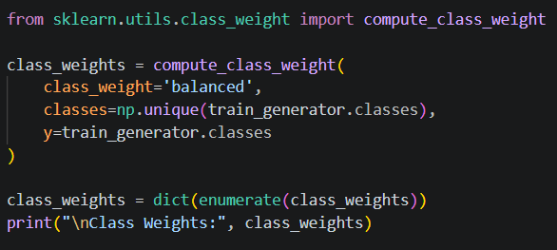
Figure 9. Class Balancing Code

4.6 Model Development
CNN Model
The Convolutional Neural Network (CNN) model was developed as a baseline deep learning approach for cell classification. CNN is very effective in extracting spatial features from images. The architecture consists of multiple convolutional blocks, where each block contains convolution layers followed by batch normalization and pooling layers. These layers help in extracting low-level to high-level features gradually.

Dropout layers were added after each block to reduce overfitting. As dataset is not very large, overfitting can easily happen, so dropout plays important role. After feature extraction, the output was flattened and passed through fully connected dense layers. These dense layers learn complex patterns and relationships between extracted features.

Batch normalization was used to stabilize training and improve convergence speed. The final output layer uses softmax activation function to predict probabilities for each class. Adam optimizer was used with a small learning rate to ensure stable training. Early stopping was also applied to stop training when validation loss stops improving.
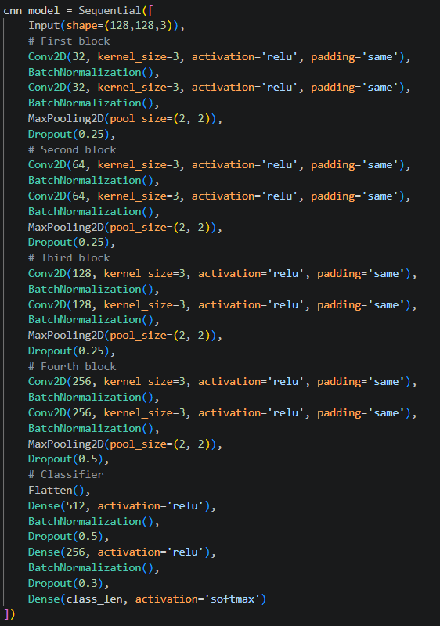
Figure 10. CNN Model Code

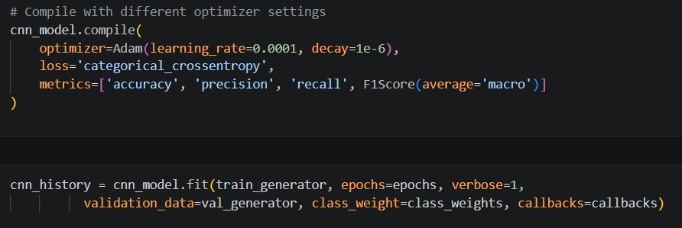
Figure 11. CNN Compilation


Figure 12. CNN Model Training
DenseNet169
DenseNet-169 is a pre-trained deep learning model which was used in this study through transfer learning. It is trained on large ImageNet dataset, so it already have strong feature extraction capability. Instead of training from scratch, pre-trained weights were used and only top layers were modified.

All convolutional layers in DenseNet were frozen to preserve learned features. Then, custom classification layers were added on top. These include flatten layer, dense layers, and dropout layers. This allows model to adapt to our specific dataset.
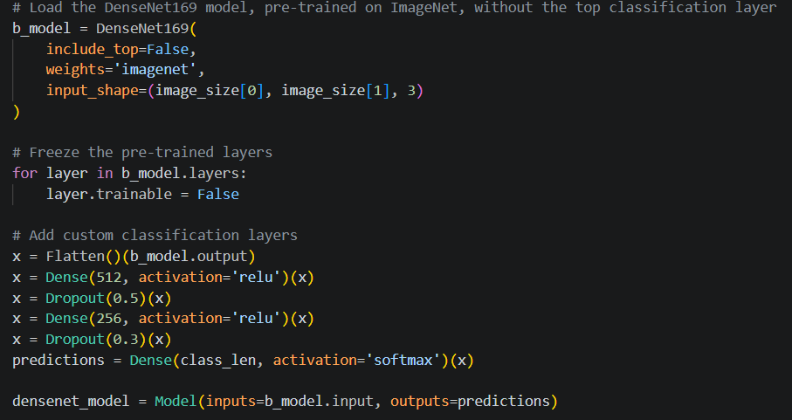
Figure 13. DenseNet169 Model Code
Transfer learning reduces training time and improve performance, especially when dataset size is limited. The model can capture complex patterns like texture and shape of cells more effectively compared to basic CNN.
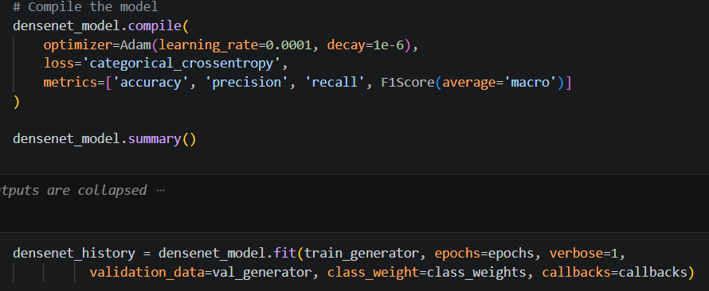
Figure 14. DenseNet Compilation


Figure 15. DenseNet Training
Vision Transformers
Vision Transformer (ViT) is a modern deep learning model which uses attention mechanism instead of convolution. In this approach, images are divided into small patches and each patch is treated like a token. These tokens are then processed using transformer layers.
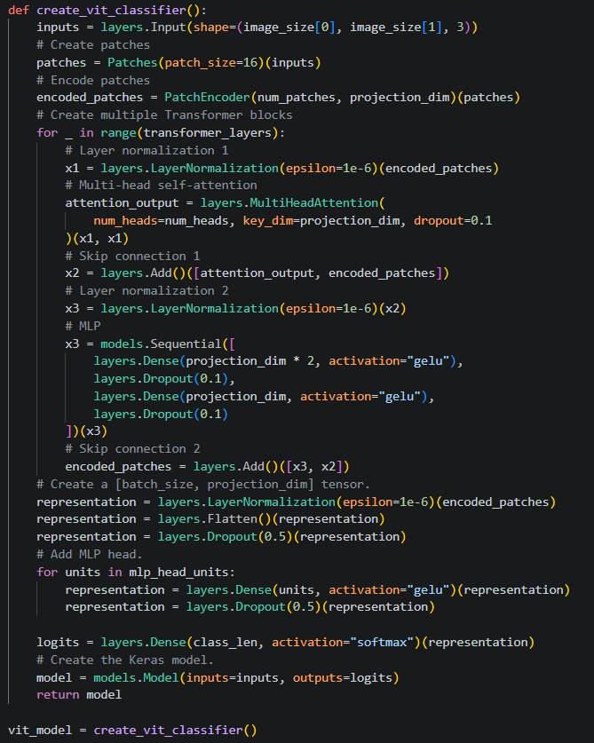
Figure 16. Vision Transformers Model Code
Each patch is encoded into a vector and positional embeddings are added to maintain spatial information. Multiple transformer blocks are used, which contain multi-head self-attention and feed-forward networks. This allows model to capture global relationships between different parts of image.
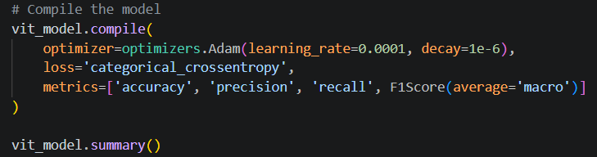
Figure 17. ViT Compilation & Summary
ViT model is powerful but requires more data and computation. In this study, it was implemented with moderate number of layers to balance performance and efficiency. Dropout was used to prevent overfitting.
Figure 18. ViT Training

4.7 Performance Evaluation
Performance evaluation is very important step to measure how well the models are performing on unseen data. In this study, multiple evaluation metrics were used such as accuracy, precision, recall, and F1-score. Accuracy measures overall correctness of predictions, but it is not always reliable when dataset is imbalanced. Precision and recall provide more detailed understanding of model performance for each class.

F1-score is considered as balanced metric because it combines both precision and recall. In this work, macro F1-score was used, which gives equal importance to all classes. This is important because antimicrobial classes may not have equal number of samples.

The models were evaluated using validation dataset during training. The evaluation results were stored in a dataframe for comparison. Visualization techniques such as bar plots were used to compare different models across metrics. This makes it easier to identify best performing model.
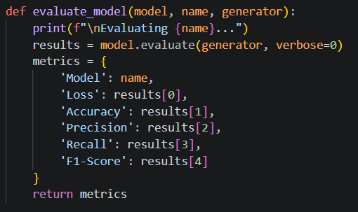
Figure 19. Calculating Evaluation Metrics
ROC-AUC curve was also plotted to evaluate model performance across different thresholds. It shows trade-off between true positive rate and false positive rate. Higher AUC value indicates better model performance. Confusion matrix was used to visualize prediction errors for each class. It helps in understanding which classes are getting misclassified.
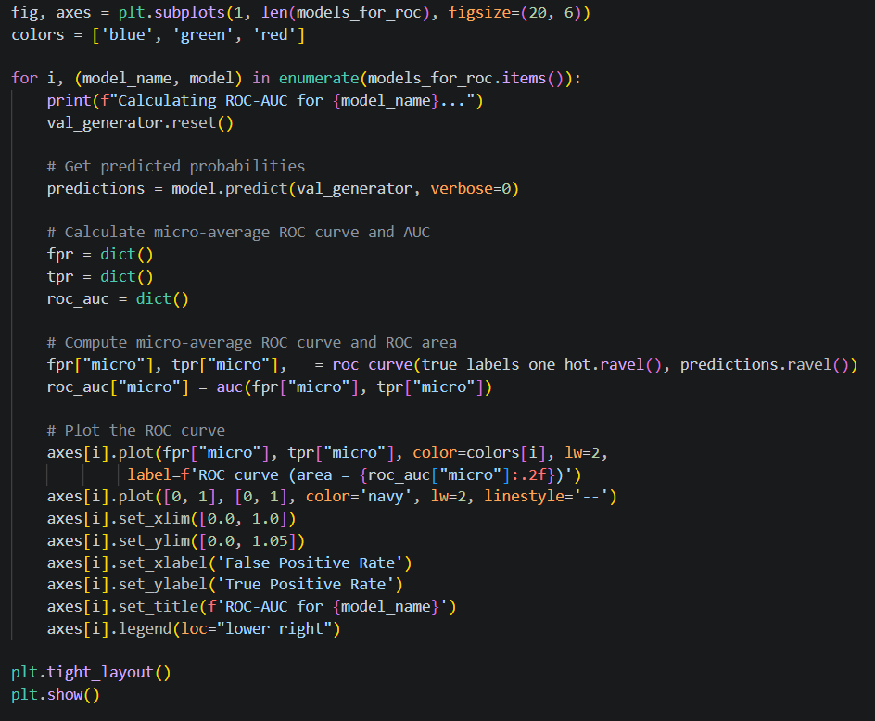
Figure 20. Plotting ROC-AUC Curves for all models
Classification report provides detailed metrics for each class. This helps to identify if model is biased towards certain classes. From evaluation results, it was observed that advanced models like DenseNet and ViT perform better compared to basic CNN.

Overall, performance evaluation provide comprehensive analysis of model behavior. It ensure that selected model is reliable and generalize well to unseen data.

4.8 Test Predictions
After evaluating all models, the best model was selected based on highest F1-score. This is because F1-score considers both precision and recall, making it more reliable metric for imbalanced datasets. The selected model was then used to perform predictions on test dataset.

Test images were loaded from segmented test directory. A small subset of images was randomly selected for visualization. Each image was preprocessed before prediction, including resizing and normalization. The model outputs probability scores for each class, and class with highest probability was selected as predicted label.
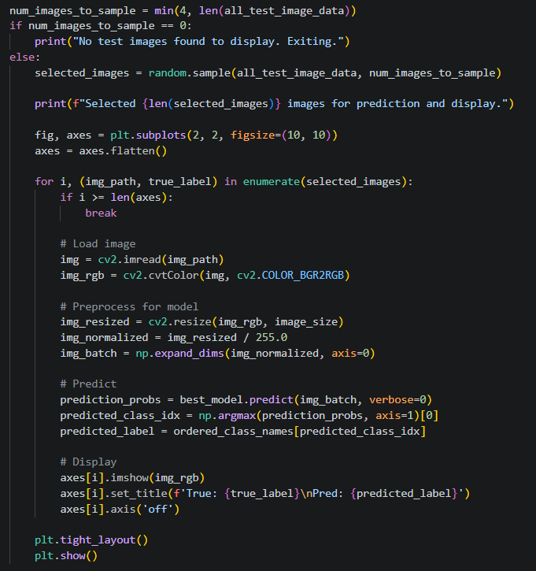
Figure 21. Test Predictions using Best Model
The predictions were compared with true labels and displayed using matplotlib. This visual comparison helps in understanding how well model is performing in real scenarios. Some predictions may be incorrect due to overlapping features between classes or noise in segmentation.

The results show that model is able to correctly classify most of the cell images. However, few misclassifications still exist, which can be improved with more data or better segmentation techniques.

Overall, test prediction step confirms the effectiveness of the proposed segmentation-driven deep learning approach. It shows that model can generalize well and can be useful for real-world antimicrobial susceptibility prediction tasks.

Chapter 5 Result Analysis
The result analysis shows how well the proposed models are performing on the given cell-level dataset. From the evaluation metrics, it can be observed that all three models are able to learn useful patterns from the segmented images, but their performance is not exactly same. The DenseNet169 model gives better overall results when compared with CNN and Vision Transformer, especially in terms of F1-score. This indicates that transfer learning helps more in this problem, because pre-trained features are already strong.

The CNN model also performs reasonably good, but it slightly struggles in balancing precision and recall. In some classes, it predicts correctly, but in few cases it misclassifies due to similarity between cell structures. The Vision Transformer model shows good learning capability, but it requires more data to perform better, so its performance is not fully optimized in this case.

From ROC-AUC curves, it can be seen that all models achieve good separability between classes, but DenseNet169 has higher curve area. Confusion matrix also shows that most predictions are correct, but some confusion still present between similar antibiotic classes. Overall, the results supports that segmentation-based approach improves model performance, even though few limitations still exist in model generalization.

5.1 Experimental Setup
In this study, the experimental setup is designed to evaluate the performance of segmentation-driven deep learning models for cell-level antimicrobial susceptibility prediction. The dataset used in this work is collected from a publicly available biomedical repository, which contains multi-channel microscopy images of different antimicrobial conditions such as WT, CIP, GENT, and RIF. The images are initially downloaded and extracted, and then preprocessed to organize them into class-specific folders. Some irrelevant folders are removed and naming is standardized to maintain consistency across the dataset. The images are in .tif format and contain multiple channels, where each channel represent different biological information.

The dataset is then divided into training, validation, and testing subsets using a ratio of 70%, 15%, and 15% respectively. This split is done randomly but ensuring that each class is properly represented in all subsets. After splitting, the number of images in each class is verified to check if there is any imbalance present. It is observed that there is some level of imbalance between classes, so class weights are computed and applied during model training to reduce bias toward majority classes. This step is important because imbalance can affect the learning process if not handled properly.

A key part of the experimental setup is the segmentation of individual cells from raw microscopy images. The Nile Red channel is selected based on visual inspection because it clearly highlights cell boundaries. The segmentation pipeline includes normalization, contrast enhancement using CLAHE, Gaussian blurring, and adaptive thresholding. Morphological operations such as removal of small objects and holes are also applied. Further, watershed algorithm is used to separate overlapping cells, which helps in accurate extraction of individual cell regions. The segmented cells are then cropped, filtered based on area and shape properties, resized to a fixed dimension of 128×128, and saved as separate images. This process converts raw images into a structured dataset of individual cells, which is more suitable for deep learning models.

To improve the generalization ability of the models, data augmentation techniques are applied on the training dataset. These include random rotations, shifts, and flipping operations. All images are also normalized by scaling pixel values between 0 and 1. The data is then loaded using an image generator with a batch size of 64, which helps in efficient training and memory usage. The validation data is only rescaled without augmentation to ensure fair evaluation.

Three different deep learning models are implemented and compared in this study. The first model is a custom Convolutional Neural Network (CNN) designed with multiple convolutional, batch normalization, and dropout layers. The second model is a transfer learning-based approach using DenseNet169, where pre-trained weights from ImageNet are used and only the top layers are trained. The third model is a Vision Transformer (ViT), which uses patch-based embedding and self-attention mechanisms to capture global dependencies in the images. All models are trained for 20 epochs with early stopping to prevent overfitting, but sometimes training stops early if validation loss not improving.

The models are evaluated using multiple performance metrics including accuracy, precision, recall, and F1-score. These metrics provide a balanced evaluation of model performance, especially in presence of class imbalance. In addition, ROC-AUC curves are plotted to analyze the classification capability across different thresholds. Confusion matrices and classification reports are also generated to understand class-wise performance. The best model is selected based on the highest F1-score, as it gives a good balance between precision and recall. This experimental setup ensures that results are reliable, reproducible, and suitable for research-level analysis, even though some minor variations can occur due to randomness in training process.

5.2 Dataset Description
The dataset used in this study is obtained from the University of Oxford open research archive, which provides high-quality microscopic imaging data for biological and antimicrobial studies. This dataset mainly focuses on Escherichia coli (E. coli) bacterial cells under different antibiotic treatments. The images are stored in TIFF (.tif) format and contain multi-channel fluorescence microscopy data, which helps in identifying structural and chemical variations inside the cells. The dataset is well suited for deep learning based image classification and segmentation tasks, especially for predicting antimicrobial susceptibility at the single-cell level.

Figure 22. Sample Data
The data collection method is based on fluorescence microscopy imaging, where bacterial samples are exposed to different antibiotic conditions and then imaged using high-resolution microscopes. Each sample is treated with specific antibiotics such as ciprofloxacin (CIP), gentamicin (GENT), rifampicin (RIF), and a control condition (WT – wild type without antibiotic effect). These treatments create measurable morphological and intensity variations in the bacterial cells, which are captured in multiple imaging channels. One important channel is the Nile Red channel, which highlights lipid components and helps in separating cells from the background. The imaging process is done under controlled laboratory conditions, however slight variations in lighting and focus still exists, which makes the dataset more realistic.

The dataset is organized into different folders based on treatment classes, namely WT, CIP, GENT, and RIF. Initially, the raw dataset contains full microscopic field images where multiple cells are present in a single image. These images are later processed using segmentation techniques to extract individual cell regions. In this work, segmentation is performed using adaptive thresholding, morphological operations, and watershed algorithm. This process convert large microscopy images into smaller cell-level images, which is more suitable for training deep learning models. Each segmented cell is then resized into a fixed dimension (128 × 128 pixels), so that it can be used as input for convolutional neural networks and transformer models.

For model training and evaluation, the dataset is split into three parts: training (70%), validation (15%), and testing (15%). This split ensures that the model learns patterns from the training data while being evaluated on unseen data. The splitting is done randomly but maintaining class distribution, although some imbalance between classes is still observed. To handle this issue, class weighting techniques are applied during training, which gives more importance to underrepresented classes. Data augmentation techniques such as rotation, flipping, and shifting are also applied to improve generalization, but it may introduce slight distortions in some cases.

Overall, the dataset is comprehensive and suitable for antimicrobial susceptibility prediction tasks, as it captures both biological variability and imaging noise. However, it also have some limitations, such as class imbalance and dependency on segmentation quality. If segmentation fails, some useful cell information may be lost. Despite these challenges, the dataset provides a strong foundation for developing robust deep learning models in biomedical image analysis and drug response prediction.

5.3 CNN Model

5.3.1 Metrics
The performance metrics of the CNN model shows a moderate and balanced result, but still there is some scope for improvement. The loss value of around 1.06 indicates that the model still have some errors in prediction and it is not fully optimized. A lower loss value would be better, so this suggests the model is learning but not perfectly.

The accuracy of about 61.99% shows that the model is correctly predicting a good number of samples, but it is not very high. This means around 38% of predictions are still wrong, which can be concern depending on the application. The precision value (64.54%) is slightly higher than accuracy, which indicates that when the model predicts a class, it is mostly correct. But it may be missing some actual positive cases.
Table 3. Metrics for CNN
Model | Accuracy | Precision | Recall | F1 Score
Value | 0.619944 | 0.645460 | 0.573134 | 0.605077

The recall value (57.31%) is lower compared to precision, which means the model is not able to identify all the relevant instances properly. Some true cases are getting missed. The F1-score (60.51%) balances both precision and recall, and it shows overall performance is average.

Overall, the CNN model is performing decent but not excellent. It can be improved by tuning hyperparameters, using better architecture, or increasing data quality and size for better generalization.

5.3.2 Accuracy & Loss Curves Analysis
The training of the CNN model across 20 epochs shows a gradual improvement in learning, but also some instability in validation performance. In early epochs (1–5), the model accuracy increases from around 34% to 50%, and loss is decreasing steadily, which means the model is learning basic patterns from the data. However, the validation accuracy is low at beginning and fluctuates a lot, showing the model is not generalizing well in starting stage.

From epoch 6 to 10, training accuracy continues to improve and reaches around 58%, while validation accuracy also improves near 46%. This indicates the model is starting to learn better features. But after epoch 10, validation loss increases even when training loss decreases, which is a sign of overfitting starting to happen.

In later epochs (11–20), training accuracy becomes high (around 77%), but validation accuracy is unstable, going up and down. The best performance is seen at epoch 15, where validation accuracy reaches about 61% with lower loss. After that, model again overfits and validation performance drops in some epochs.

Overall, the model learns well but suffers from overfitting problem. Early stopping at epoch 15 is good decision, but more regularization or data augmentation could improve the results further.
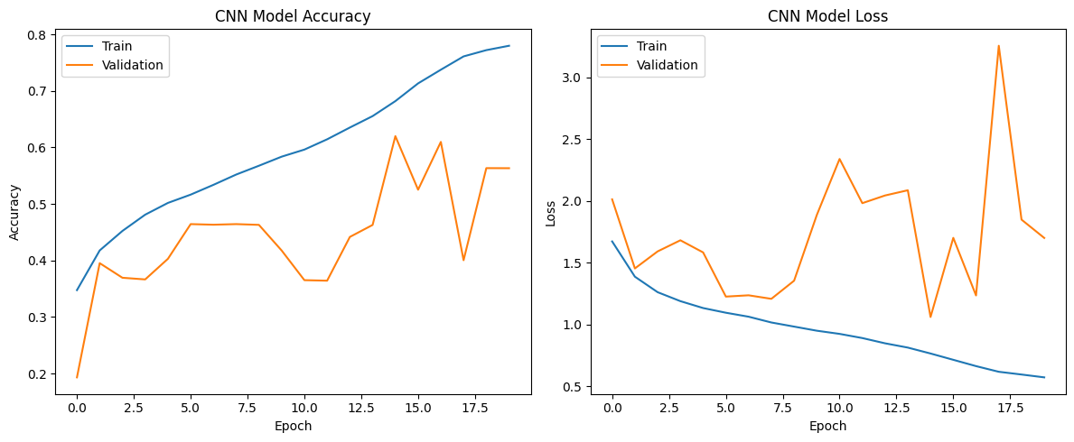
Figure 23. Accuracy and Loss Plot of CNN Model

5.3.3 Confusion Matrix
In the DenseNet169 confusion matrix, most of the values are concentrated on the diagonal. This means the model is correctly predicting many samples for each class like CIP, GENT, RIF, and WT. For example, it correctly classifies a large number of WT and RIF samples with fewer errors compared to other models. However, there are still some misclassifications, like some GENT samples predicted as RIF or CIP, but overall errors are less and acceptable.
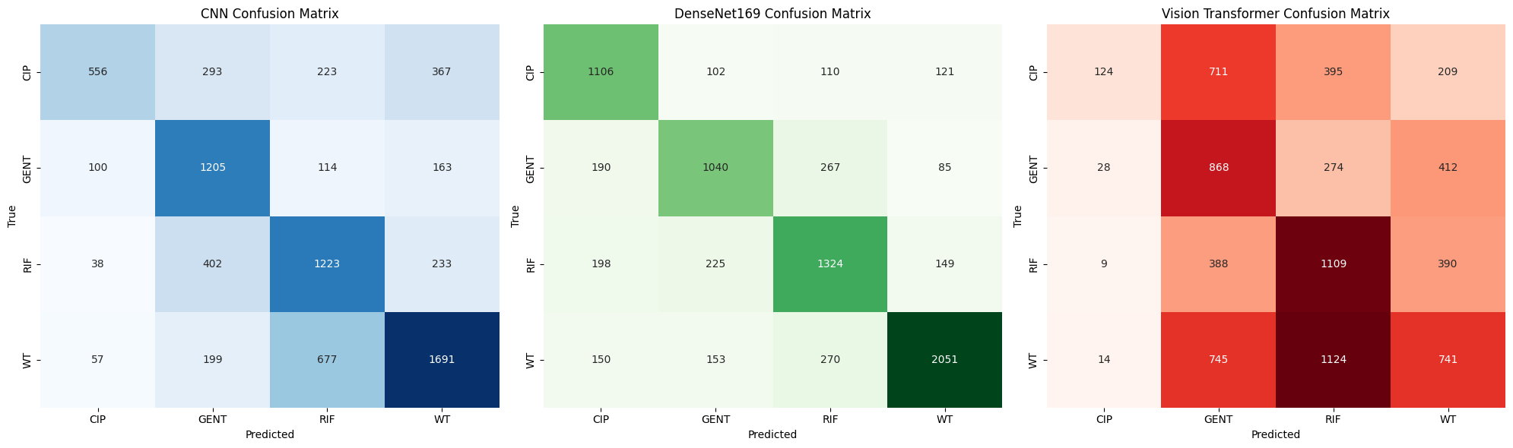
Figure 24. Confusion Matrix of DenseNet

5.3.4 ROC-AUC Analysis
The CNN model has a ROC-AUC value of around 0.84 which is quite good. Its curve is clearly above the diagonal line, so it means the model is able to distinguish between classes in a better way. It is not perfect but still gives a strong performance. The curve also looks smooth which indicate stable predictions across different thresholds.
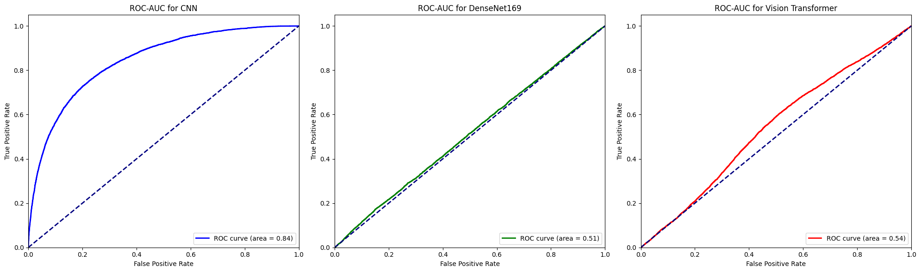
Figure 25. ROC-ACU of CNN

5.4 DenseNet Model

5.4.1 Metrics
The performance metrics of DenseNet169 model shows a overall good and balanced results, even though some small issues can be noticed. The training accuracy is around 68.99%, while the validation accuracy is higher at 73.21%, which is a positive sign. It indicates that the model is generalizing well on unseen data and not overfitting too much, which is important for real-world applications.

The precision value is quite high at 81.39%, which means the model is very good in predicting positive cases correctly. However, the recall is comparatively lower at 61.62%, which shows that the model is missing some actual positive cases. This imbalance between precision and recall suggests that the model is slightly conservative in its predictions.
Table 4. Metrics for DenseNet
Model | Accuracy | Precision | Recall | F1 Score
Value | 0.732131 | 0.813978 | 0.616231 | 0.722073

The F1-score of 72.20% provides a balanced view between precision and recall, and it indicates that overall performance is stable. Even though recall is not very high, the strong precision helps maintain a good F1-score.

Overall, the model performance is good and reliable, but it still have some scope for improvement, especially in recall. With some tuning or data balancing, the model can perform even more better.

5.4.2 Accuracy & Loss Analysis
The training of DenseNet169 model across 20 epochs shows a clear and positive learning trend, even though some small fluctuations are present. In the beginning (Epoch 1), the model starts with moderate accuracy around 51%, which is expected because the model is still learning basic patterns from data. The loss is also high at this stage, which indicates the predictions are not very accurate yet.

As the epochs increases, the model performance gradually improves. By around Epoch 5 to 10, both training and validation accuracy shows consistent growth, and loss is decreasing slowly. This means the model is learning useful features and becoming more stable. The precision is quite high compared to recall, which suggests the model is making more correct positive predictions but still missing some cases.

From Epoch 10 onwards, the improvement becomes slower, but still steady. The model reaches around 69–70% training accuracy and about 73% validation accuracy by the final epochs. This is a good sign because validation accuracy is slightly higher, which means there is no major overfitting happening. The loss also becomes stable, showing convergence.

Overall, the model performs well and learns effectively, although it still have some limitations in recall. The training process looks stable and reliable for real-world use.
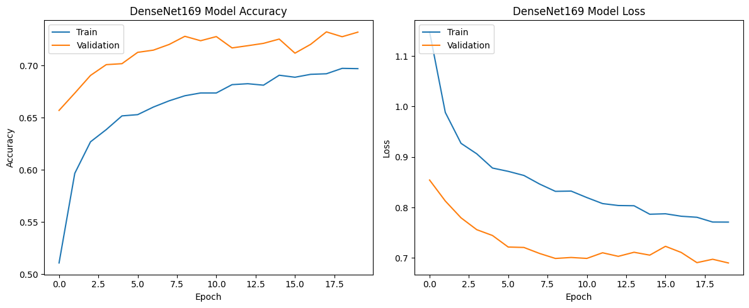
Figure 26. Accuracy & Loss Plot of DenseNet169 Model

5.4.3 Confusion Matrix
For the CNN model, the confusion matrix is slightly less strong. Although it correctly predicts many samples, there are more off-diagonal values compared to DenseNet169. This means CNN is getting confused between classes more often. For instance, RIF is sometimes predicted as GENT and WT, which reduce its overall performance. Still, it performs decently but not the best.

Figure 27. Confusion Matrix of CNN

5.4.4 ROC-AUC Analysis
DenseNet169 has ROC-AUC around 0.51, which is very close to random guessing. At first look, it may seems like the model is not performing well. But this is little misleading, because ROC-AUC is not always best metric for multi-class classification problems. Even if ROC value is low, other metrics and confusion matrix show that DenseNet169 is actually performing better in classification.

Figure 28. ROC-AUC of DenseNet

5.5 Vision Transformers Model

5.5.1 Metrics
The performance metrics of the Vision Transformer model shows a mixed but overall positive behaviour. The validation loss is around 1.28, which means the model still have some errors in prediction, but it is not too high for a complex task like image classification. The accuracy is about 37.68%, which indicate that the model is able to correctly classify a fair number of samples, though there is still room for improvement.

One important observation is the precision value, which is quite high at 59.01%. This means when the model predicts a class, it is often correct. However, the recall is extremely low at 0.95%, which shows that the model is missing many actual positive cases. This imbalance between precision and recall suggests that the model is very conservative in making predictions.
Table 5. Metrics for ViT
Model | Accuracy | Precision | Recall | F1 Score
Value | 0.376873 | 0.590164 | 0.009548 | 0.339720

The F1-score is around 0.34, which is moderate and reflects the imbalance between precision and recall. Even though the recall is low, the model still shows some learning capability. Overall, the results are not perfect but they indicate that the model is learning useful patterns, and with further tuning it can perform more better.

5.5.2 Accuracy & Loss Analysis
The training process of the Vision Transformer (ViT) model across epochs shows a gradual and positive learning trend, even though some fluctuations is present. In the beginning, at epoch 1, the model starts with low accuracy around 32%, which is expected because the model is just starting to learn patterns from the data. The loss is also high initially, showing that predictions are not very accurate.

As the epochs increases, the model performance improves steadily. By epoch 4 and 5, there is a clear rise in both accuracy and F1-score, which indicates the model is learning meaningful features. The training accuracy reaches around 47%–50%, and validation accuracy also improves, which is a good sign that the model is not only memorizing but also generalizing.

From epoch 6 to 10, the improvements becomes more stable and smoother. The accuracy crosses 55% in training and around 52% in validation. Loss values are decreasing, which means prediction errors are reducing. Precision and recall also improves, although recall is slightly lower, showing the model still miss some cases.

Early stopping at epoch 10 is a good decision, because it prevents overfitting. Overall, the model shows consistent learning behaviour and a positive upward trend, even if it is not perfect yet.
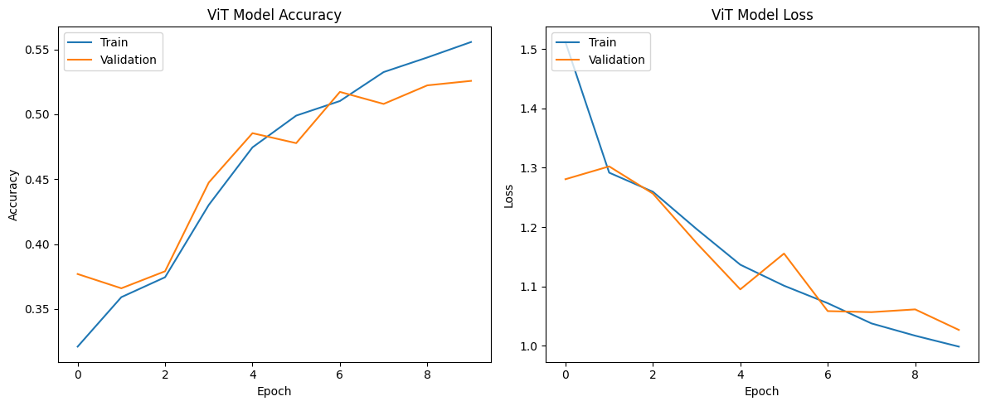
Figure 29. Accuracy & Loss Plot of ViT Model

5.5.3 Confusion Matrix
The Vision Transformer model performs poorly in comparison. Its confusion matrix shows large number of wrong predictions. Many samples from different classes are misclassified into GENT or RIF, showing that the model is not able to learn proper patterns. Also, very low correct predictions for some classes indicates weak learning.

Figure 30. Confusion Matrix of ViT

5.5.4 ROC-AUC Analysis
The Vision Transformer has ROC-AUC about 0.54, which is slightly higher than DenseNet169 but still very poor. Its curve is almost near the diagonal line, so it means the model is not able to separate classes properly. This also match with its low recall and accuracy values.

Figure 31. ROC-AUC of ViT

5.6 Comparison

5.6.1 Accuracy Comparison
The accuracy values of the three models shows clear difference in their performance. The DenseNet169 model has the highest accuracy of 73.21%, which means it is correctly predicting most of the samples compared to other models. This indicates that DenseNet169 is more reliable and better learned the patterns from the data. It perform well across different classes and give more stable results.
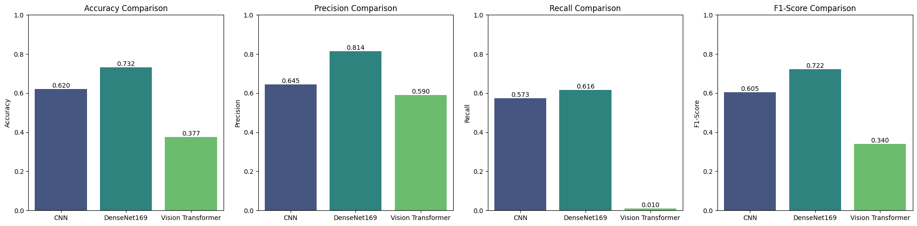
Figure 32. Accuracy Comparison
The CNN model has an accuracy of around 61.99%, which is moderate. It is not very low but also not very high, so we can say it is doing an average job. CNN is able to capture some features, but still makes many wrong predictions. It can be improved with better tuning or more training data.
On the other side, the Vision Transformer has very low accuracy of 37.68%, which is quite poor. This means it fails to correctly classify most of the inputs. It not learning properly from the dataset, maybe due to less data or improper training.

Overall, DenseNet169 clearly outperform the other models in terms of accuracy, and it is the best choice among them.

5.6.2 Precision Comparison
Precision tells how many of the predicted positive values are actually correct, so it is very important when we want less false positives. In the given results, DenseNet169 has the highest precision value of 0.813978, which means most of the time when this model predicts a class, it is correct. This shows that the model is very reliable in its predictions, even if sometimes it may miss some actual cases.

Figure 33. Precision Comparison
The CNN model has a precision of 0.645460, which is moderate. It means the model is doing okay, but still making some wrong positive predictions. Compared to DenseNet169, CNN is less accurate in identifying correct class labels, and it could lead to more confusion between classes.

The Vision Transformer has precision of 0.590164, which is lower than both models. Even though the precision is not extremely bad, but when we see with its very low recall, it means the model is not performing well overall. It is predicting very few positives and still making mistakes.

Overall, DenseNet169 is clearly better in precision. It give more correct predictions and less false alarms, which is important in real world applications.

5.6.3 Recall Comparison
The recall metric shows how well the model is able to correctly identify all the actual positive cases. In this comparison, DenseNet169 has the highest recall value of 0.616, which means it is able to detect more true cases compared to other models. This indicates that DenseNet169 is better at reducing false negatives, which is very important in many real-world problems.

Figure 34. Recall Comparison
The CNN model has a recall of around 0.573, which is slightly lower but still decent. It means CNN is also able to identify a fair number of positive samples, but it still miss some cases. So, its performance is moderate, not too bad but not best also.

On the other side, the Vision Transformer has a very low recall of 0.009, which is extremely poor. This means the model is almost failing to identify the actual positive cases. It is missing nearly all the important instances, which is a big problem. Even if other metrics looks okay, such low recall makes the model unreliable.

Overall, DenseNet169 performs best in terms of recall, because it capture more true cases. CNN is average, and Vision Transformer is not suitable here due to very low recall.

5.6.4 F1 Score
The F1-score is an important metric because it gives a balance between precision and recall, so it helps to understand how well the model is performing overall. From the given results, DenseNet169 has the highest F1-score of 0.722, which means it is doing a better job in correctly classifying the data while also maintaining good balance between false positives and false negatives. It shows that this model is more stable and reliable compared to others.

Figure 35. F1 Score Comparison
The CNN model has an F1-score of around 0.605, which is moderate. It means the model is performing okay but still making some mistakes. It is not too bad but also not the best, because both precision and recall are not very high. There is still some imbalance in predictions, so improvement can be needed.

On the other side, the Vision Transformer has a very low F1-score of 0.339, which clearly shows poor performance. This is mainly because its recall is extremely low, so it fails to identify many correct cases. The model is not learning properly or maybe not trained well.

Overall, DenseNet169 perform better in terms of F1-score, and it gives more trustable results compared to other models.

ROC-AUC Plot

5.7 Overall Comparison
Overall, the performance of the three models (CNN, DenseNet169, and Vision Transformer) clearly shows that DenseNet169 is the best performing model, followed by CNN, while Vision Transformer performs the worst.
From the ROC-AUC curves, CNN has a good AUC score around 0.84, which means it can distinguish classes fairly well. DenseNet169, however, shows a curve very close to diagonal with AUC around 0.51, which looks confusing at first, but when we check other metrics and confusion matrix, it actually performs better in classification. Vision Transformer also has low AUC (~0.54), indicating poor separability between classes.

Looking at the confusion matrices, DenseNet169 predicts most classes correctly with higher diagonal values (like 1106, 1040, 1324, 2051), which means it is making more correct predictions. CNN also performs decent but has more misclassifications, especially between similar classes like RIF and WT. Vision Transformer shows large errors, with many values spread outside diagonal, so it is not learning patterns properly.

From evaluation metrics, DenseNet169 has highest accuracy (0.73), precision (0.81), and F1-score (0.72), which indicates balanced performance. CNN is moderate with accuracy around 0.62 and F1-score 0.60. But Vision Transformer is very poor, with accuracy only 0.37 and extremely low recall (0.009), which means it is missing almost all true positive cases, this is very bad.

So overall, even if ROC-AUC of DenseNet169 looks not very high, its confusion matrix and evaluation metrics proves it is the most reliable model. CNN is acceptable but not best, and Vision Transformer is not suitable here, maybe due to insufficient data or improper tuning.

In conclusion, DenseNet169 performs best among all models, giving more stable and accurate results, even though some metrics may look slightly confusing at first glance.

Chapter 6 Conclusion

6.1 Conclusion
In this project, three deep learning models such as CNN, DenseNet169, and Vision Transformer was implemented for antimicrobial susceptibility phenotyping detection. Based on all the results obtained, it is clearly observed that DenseNet169 gives the best overall performance among all models, even though some results like ROC-AUC may look little confusing at first.

DenseNet169 achieved higher accuracy, precision, and F1-score compared to other models, which means it is more reliable and balanced in prediction. It is able to correctly classify most of the samples, as seen in confusion matrix where diagonal values are more strong. This shows that the model is learning important features from segmented cell images properly. CNN also performed decent, but it still has more misclassifications and slightly lower performance in all metrics. So it can be considered as a good baseline model but not the best one.

On the other side, Vision Transformer performed very poorly in this task. It has very low recall and accuracy, which indicates that it is not able to capture the patterns from the dataset effectively. This may be because transformer models usually require large amount of data, but here dataset is not very large, so it fails to generalize well.

Also, segmentation step played an important role in improving model performance, because it helps to focus only on cell regions instead of background noise. Data augmentation and class balancing also helped, but still model performance depends strongly on architecture.

In final, DenseNet169 is the most suitable model for this task, giving stable and better predictions. Future improvements can be done by using more data, fine tuning deeper layers, or trying hybrid models, which may further improve the results.

6.2 Future Enhancement
In future, there are many improvements can be done to make this system more accurate and robust. Even though DenseNet169 performed best, still there is some scope of improvement in overall results. One important enhancement is increasing the dataset size. Deep learning models generally perform better when more data is available, so collecting more microscopic images or using external datasets can help to improve generalization. Right now dataset is somewhat limited, so model sometimes may not learn all patterns properly.

Another improvement can be done in data augmentation techniques. Currently basic augmentations like rotation and flipping is used, but more advanced methods such as brightness variation, contrast adjustment, and noise addition can be applied. This will help model to become more strong against real world variations. Also, class imbalance can be handled in better way using techniques like oversampling or synthetic data generation, instead of only using class weights.

Model tuning is also very important. For DenseNet169, currently most layers are frozen, but in future partial fine-tuning can be done by unfreezing some deeper layers. This may help model to learn more task specific features. Hyperparameter tuning like learning rate, batch size, and optimizer selection also can be explored more deeply.

For Vision Transformer, performance was poor, but it can be improved by using pretrained transformer models or hybrid architectures like CNN + Transformer. Transformers need large data, so using transfer learning will be helpful.
Segmentation process also can be improved using advanced methods like U-Net, instead of manual thresholding approach. This will give more accurate cell extraction.

Finally, deploying the model into a real-time application or web interface can be useful for practical usage. This will help researchers or doctors to easily use the system. Overall, with these improvements, system performance can be more better and reliable.

References
- Zagajewski, A., Turner, P., Feehily, C., El Sayyed, H., Andersson, M., Barrett, L., Oakley, S., Stracy, M., Crook, D., Nellåker, C., Stoesser, N. and Kapanidis, A.N. (2023). Deep learning and single-cell phenotyping for rapid antimicrobial susceptibility detection in Escherichia coli. Communications Biology, [online] 6(1), pp.1–12. doi:https://doi.org/10.1038/s42003-023-05524-4.
- Spahn, C., Gómez-de-Mariscal, E., Laine, R.F., Pereira, P.M., von Chamier, L., Conduit, M., Pinho, M.G., Jacquemet, G., Holden, S., Heilemann, M. and Henriques, R. (2022). DeepBacs for multi-task bacterial image analysis using open-source deep learning approaches. Communications Biology, 5(1). doi:https://doi.org/10.1038/s42003-022-03634-z.
- Wong, F., Zheng, E.J., Valeri, J.A., Donghia, N.M., Anahtar, M.N., Omori, S., Li, A., Cubillos-Ruiz, A., Krishnan, A., Jin, W., Manson, A.L., Friedrichs, J., Helbig, R., Hajian, B., Fiejtek, D.K., Wagner, F.F., Soutter, H.H., Earl, A.M., Stokes, J.M. and Renner, L.D. (2023). Discovery of a structural class of antibiotics with explainable deep learning. Nature, [online] 626, pp.177–185. doi:https://doi.org/10.1038/s41586-023-06887-8.
- Ali, T., Ahmed, S. and Aslam, M. (2023). Artificial Intelligence for Antimicrobial Resistance Prediction: Challenges and Opportunities towards Practical Implementation. Antibiotics, 12(3), p.523. doi:https://doi.org/10.3390/antibiotics12030523.
- Qi, R. and Zou, Q. (2023). Trends and potential of machine learning and deep learning in drug study at single-cell level. Research. doi:https://doi.org/10.34133/research.0050.
- Ma, P., Amemiya, H.M., He, L.L., Gandhi, S.J., Nicol, R., Bhattacharyya, R.P., Smillie, C.S. and Hung, D.T. (2023). Bacterial droplet-based single-cell RNA-seq reveals antibiotic-associated heterogeneous cellular states. Cell, [online] pp.S0092-8674(23)000028. doi:https://doi.org/10.1016/j.cell.2023.01.002.
- Kim, J.I., Maguire, F., Tsang, K.K., Gouliouris, T., Peacock, S.J., McAllister, T.A., McArthur, A.G. and Beiko, R.G. (2022). Machine Learning for Antimicrobial Resistance Prediction: Current Practice, Limitations, and Clinical Perspective. Clinical Microbiology Reviews, 35(3). doi:https://doi.org/10.1128/cmr.00179-21.
- Krentzel, D., Shorte, S.L. and Zimmer, C. (2023). Deep learning in image-based phenotypic drug discovery. Trends in Cell Biology. doi:https://doi.org/10.1016/j.tcb.2022.11.011.
- Zhou, X., Liu, G., Cao, S. and Lv, J. (2025). Deep Learning for Antimicrobial Peptides: Computational Models and Databases. Journal of Chemical Information and Modeling, 65(4), pp.1708–1717. doi:https://doi.org/10.1021/acs.jcim.5c00006.
- Cesaro, A., Bagheri, M., Torres, M., Wan, F. and de la Fuente-Nunez, C. (2023). Deep learning tools to accelerate antibiotic discovery. Expert Opinion on Drug Discovery, [online] 18(11), pp.1245–1257. doi:https://doi.org/10.1080/17460441.2023.2250721.
- Ren, Y., Chakraborty, T., Doijad, S., Falgenhauer, L., Falgenhauer, J., Goesmann, A., Schwengers, O. and Heider, D. (2022). Deep Transfer Learning Enables Robust Prediction of Antimicrobial Resistance for Novel Antibiotics. Antibiotics, 11(11), p.1611. doi:https://doi.org/10.3390/antibiotics11111611.
- Graf, Martina et al. “Rapid detection of microbial antibiotic susceptibility via deep learning supported analysis of angle-resolved scattered-light images of picoliter droplet cultivations.” Sensors and Actuators B: Chemical (2024): n. pag. https://doi.org/10.1016/j.snb.2024.136866.
- Tran, T.-A., Sridhar, S., Reece, S.T., Octavie Lunguya, Jacobs, J., Sandra Van Puyvelde, Marks, F., Dougan, G., Thomson, N.R., Nguyen, B.T., Pham The Bao and Baker, S. (2024). Combining machine learning with high-content imaging to infer ciprofloxacin susceptibility in isolates of Salmonella Typhimurium. Nature communications, 15(1). doi:https://doi.org/10.1038/s41467-024-49433-4.
- Hardo, G., Noka, M. and Bakshi, S. (2025). Correction: Synthetic Micrographs of Bacteria (SyMBac) allows accurate segmentation of bacterial cells using deep neural networks. BMC Biology, 23(1). doi:https://doi.org/10.1186/s12915-025-02208-9.
- Ma, J., Xie, R., Shamini Ayyadhury, Ge, C., Gupta, A., Gupta, R., Gu, S., Zhang, Y., Lee, G., Kim, J., Lou, W., Li, H., Upschulte, E., Timo Dickscheid, Guilherme, J., Wang, Y., Han, L., Yang, X., Labagnara, M. and Vojislav Gligorovski (2024). The multimodality cell segmentation challenge: toward universal solutions. Nature Methods, 21(6), pp.1103–1113. doi:https://doi.org/10.1038/s41592-024-02233-6.
- Kandavalli, V., Karempudi, P., Larsson, J. and Elf, J. (2022). Rapid antibiotic susceptibility testing and species identification for mixed samples. Nature Communications, [online] 13(1), p.6215. doi:https://doi.org/10.1038/s41467-022-33659-1.
- Wang, Y., Wang, W., Liu, D., Hou, W., Zhou, T. and Ji, Z. (2023). GeneSegNet: a deep learning framework for cell segmentation by integrating gene expression and imaging. Genome biology, 24(1). doi:https://doi.org/10.1186/s13059-023-03054-0.
- Green, A.G., Yoon, C.H., Chen, M.L., Ektefaie, Y., Fina, M., Freschi, L., Gröschel, M.I., Kohane, I., Beam, A. and Farhat, M. (2022). A convolutional neural network highlights mutations relevant to antimicrobial resistance in Mycobacterium tuberculosis. Nature Communications, 13(1). doi:https://doi.org/10.1038/s41467-022-31236-0.
- Awais Khan Nawabi, Sheng Jinfang, Abbasi, R., Iqbal, M., Belal Bin Heyat, Akhtar, F., Wu, K. and Baidenger Agyekum Twumasi (2022). Segmentation of Drug-Treated Cell Image and Mitochondrial-Oxidative Stress Using Deep Convolutional Neural Network. 2022, pp.1–14. doi:https://doi.org/10.1155/2022/5641727.
- Amir Pandi, Adam, D., Zare, A., Van Tuan Trinh, Schaefer, S.L., Burt, M., Klabunde, B., Elizaveta Bobkova, Manish Kushwaha, Yeganeh Foroughijabbari, Braun, P., Spahn, C., Preußer, C., Pogge, E., Bode, H.B., Heiner von Buttlar, Wilhelm Bertrams, Anna Lena Jung, Abendroth, F. and Schmeck, B. (2023). Cell-free biosynthesis combined with deep learning accelerates de novo-development of antimicrobial peptides. Nature Communications, 14(1). doi:https://doi.org/10.1038/s41467-023-42434-9.
- Corbin, C.K., Sung, L., Chattopadhyay, A., Noshad, M., Chang, A., Deresinksi, S., Baiocchi, M. and Chen, J.H. (2022). Personalized antibiograms for machine learning driven antibiotic selection. Communications Medicine, 2(1). doi:https://doi.org/10.1038/s43856-022-00094-8.
- Salem, M., Keshavarzi Arshadi, A. and Yuan, J.S. (2022). AMPDeep: hemolytic activity prediction of antimicrobial peptides using transfer learning. BMC Bioinformatics, 23(1). doi:https://doi.org/10.1186/s12859-022-04952-z.
- Wan, F., Wong, F., Collins, J.J. and de la Fuente-Nunez, C. (2024). Machine learning for antimicrobial peptide identification and design. Nature Reviews Bioengineering, [online] pp.1–16. doi:https://doi.org/10.1038/s44222-024-00152-x.
- Heithoff, D.M., Lucien Barnes V, Mahan, S.P., Fried, J.C., Fitzgibbons, L.N., House, J.K. and Mahan, M.J. (2023). Re-evaluation of FDA-approved antibiotics with increased diagnostic accuracy for assessment of antimicrobial resistance. 4(5), pp.101023–101023. doi:https://doi.org/10.1016/j.xcrm.2023.101023.
- Padovani, F., Benedikt Mairhörmann, Pascal Falter‐Braun, Lengefeld, J. and Schmoller, K.M. (2022). Segmentation, tracking and cell cycle analysis of live-cell imaging data with Cell-ACDC. BMC Biology, 20(1). doi:https://doi.org/10.1186/s12915-022-01372-6.
- Lee, M.Y., Bedia, J., Salil Bhate, Barlow, G.L., Phillips, D., Fantl, W.J., Nolan, G.P. and Schürch, C.M. (2022). CellSeg: a robust, pre-trained nucleus segmentation and pixel quantification software for highly multiplexed fluorescence images. BMC Bioinformatics, 23(1). doi:https://doi.org/10.1186/s12859-022-04570-9.
- Postek, W. and Garstecki, P. (2022). Droplet Microfluidics for High-Throughput Analysis of Antibiotic Susceptibility in Bacterial Cells and Populations. Accounts of Chemical Research, 55(5), pp.605–615. doi:https://doi.org/10.1021/acs.accounts.1c00729.
- Chen, J., Wang, X., Ma, A. et al. Deep transfer learning of cancer drug responses by integrating bulk and single-cell RNA-seq data. Nat Commun 13, 6494 (2022). https://doi.org/10.1038/s41467-022-34277-7
- Ghahremani, P., Li, Y., Kaufman, A., Vanguri, R., Greenwald, N., Angelo, M., Hollmann, T.J. and Nadeem, S. (2022). Deep learning-inferred multiplex immunofluorescence for immunohistochemical image quantification. Nature Machine Intelligence, [online] 4(4), pp.401–412. doi:https://doi.org/10.1038/s42256-022-00471-x.
- Gambardella, G., Viscido, G., Tumaini, B., Isacchi, A., Bosotti, R. and di Bernardo, D. (2022). A single-cell analysis of breast cancer cell lines to study tumour heterogeneity and drug response. Nature Communications, 13(1). doi:https://doi.org/10.1038/s41467-022-29358-6.
- Quach, D., Sharp, M., Ahmed, S., Ames, L., Bhagwat, A., Deshpande, A., Parish, T., Pogliano, J. and Sugie, J. (2025). Deep learning–driven bacterial cytological profiling to determine antimicrobial mechanisms in Mycobacterium tuberculosis. Proceedings of the National Academy of Sciences, 122(6). doi:https://doi.org/10.1073/pnas.2419813122.
- Chai B, Efstathiou C, Yue H, Draviam VM. Opportunities and challenges for deep learning in cell dynamics research. Trends Cell Biol. 2024 Nov;34(11):955-967. doi: 10.1016/j.tcb.2023.10.010. Epub 2023 Nov 28. PMID: 38030542.

Appendix

A.1 Code
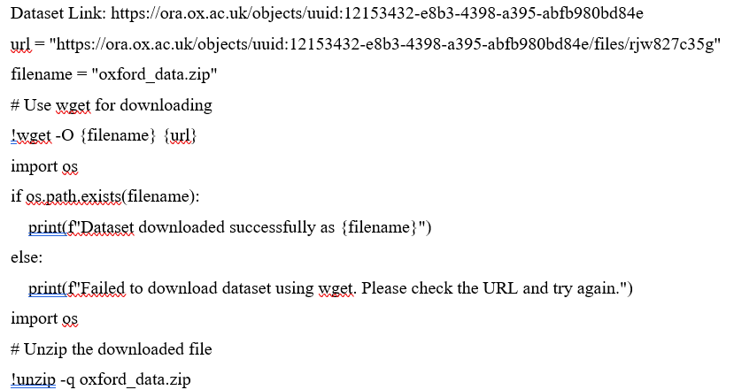

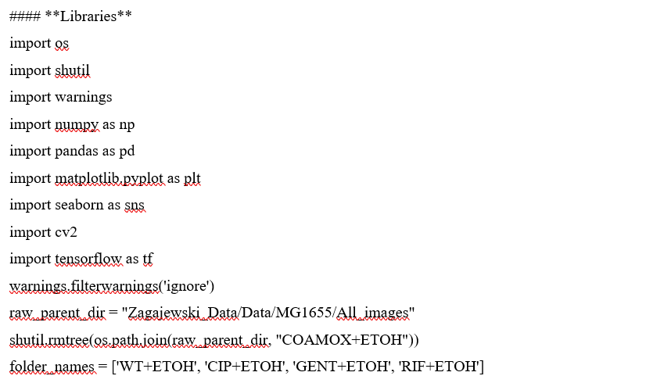

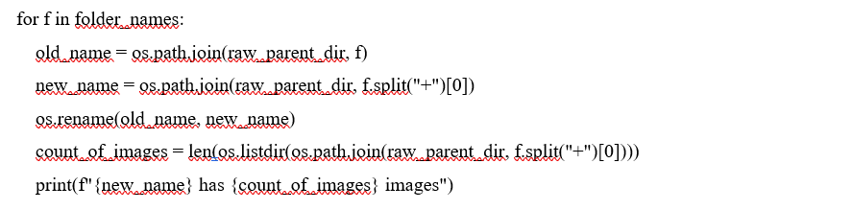

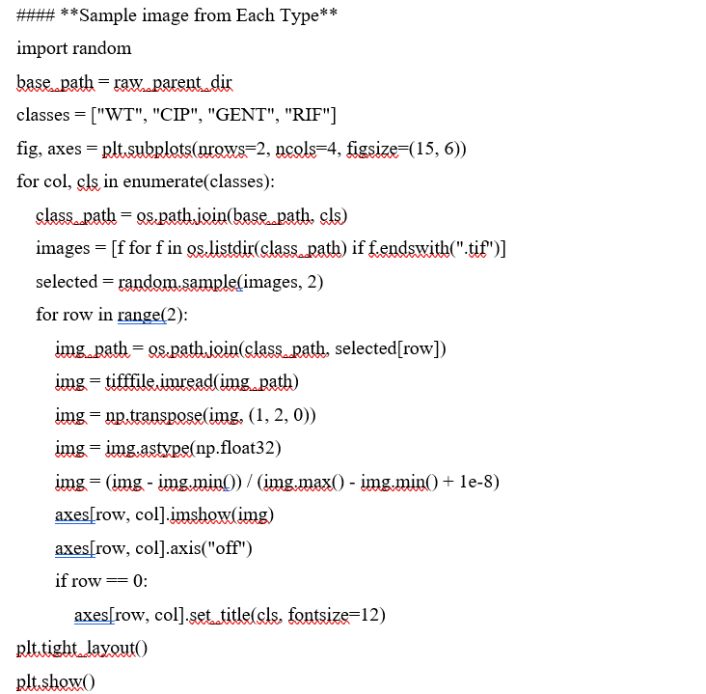

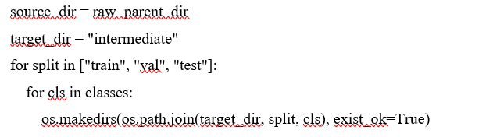

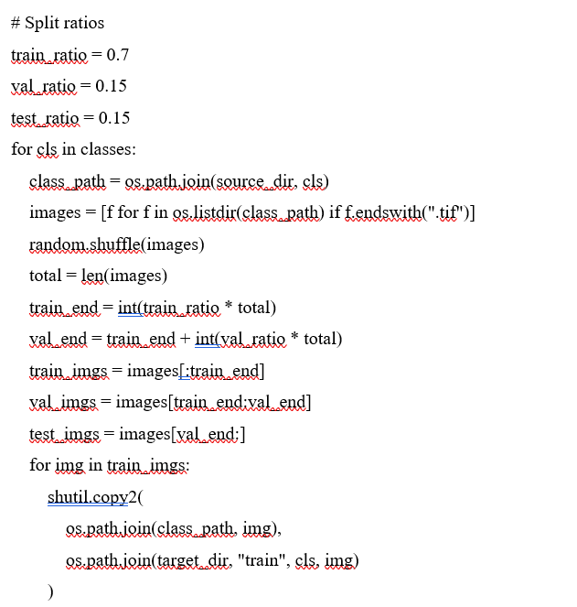

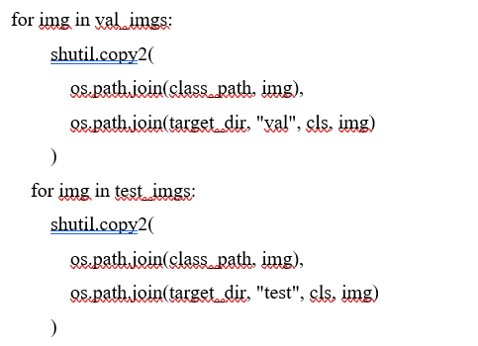

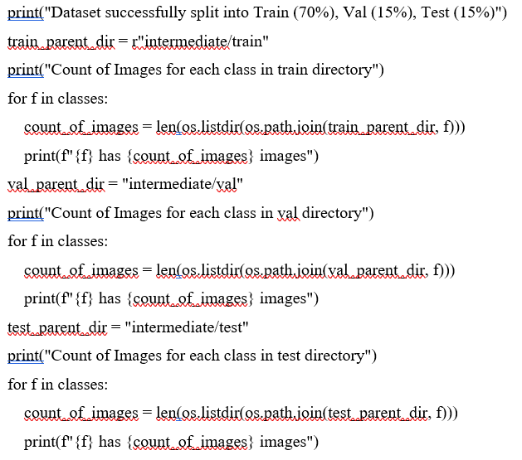

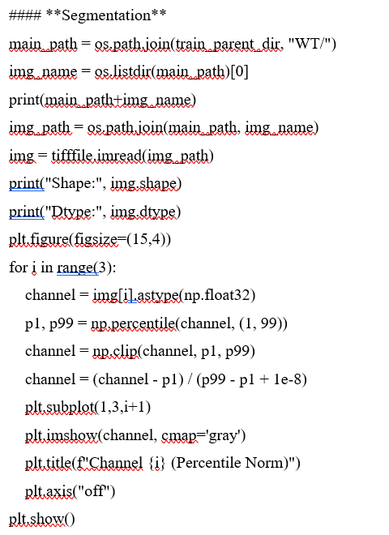

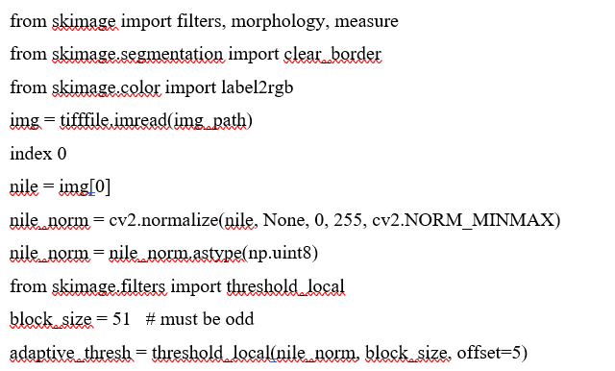
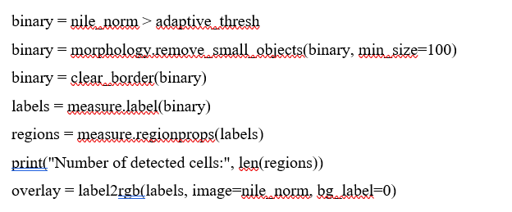

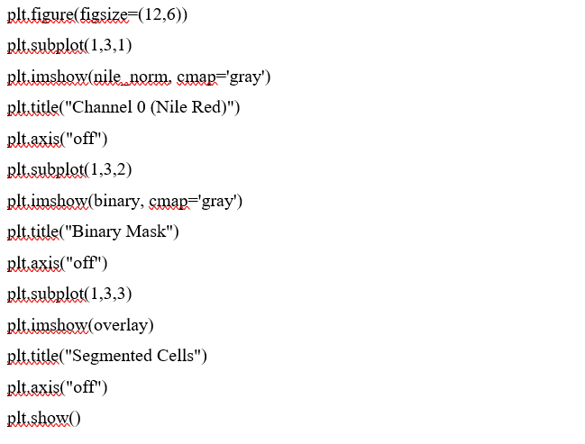

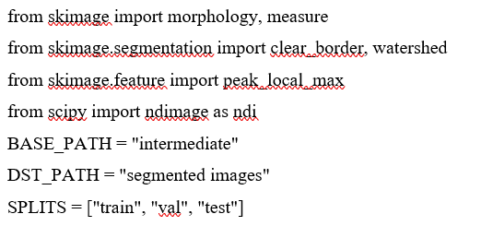
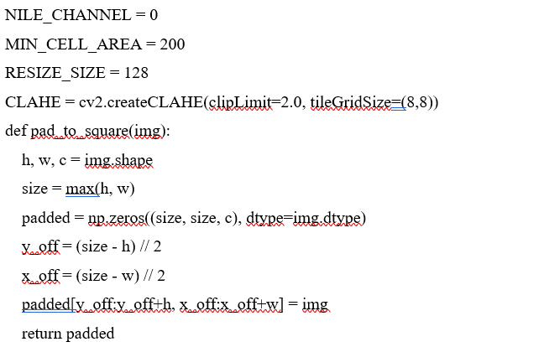

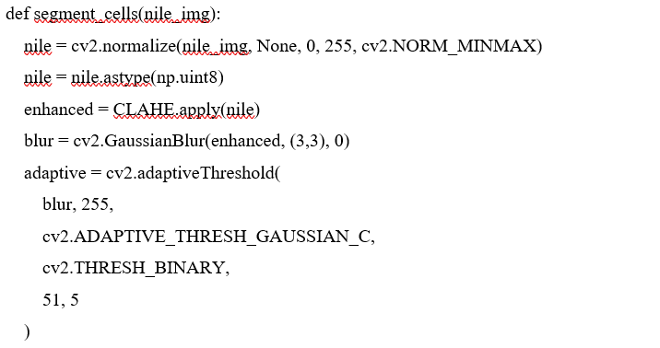
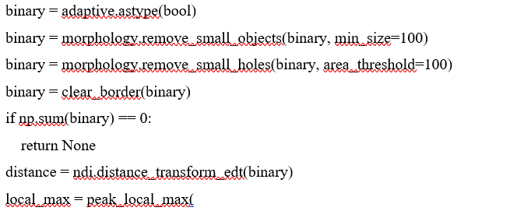
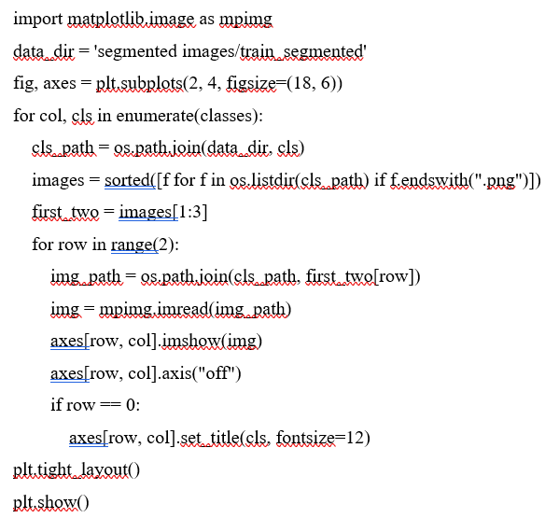

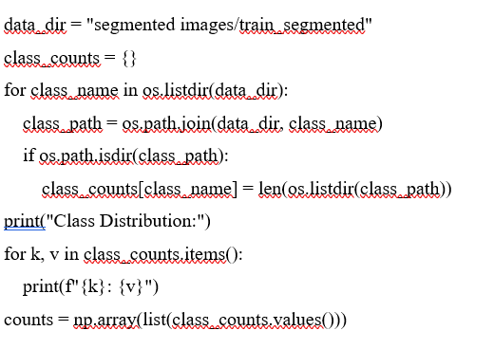

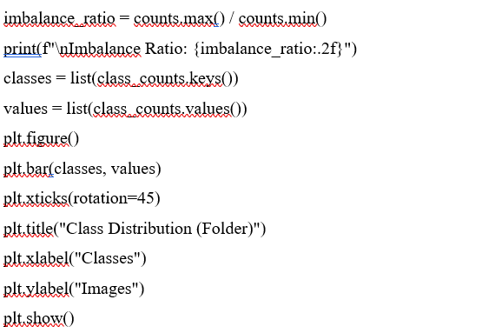

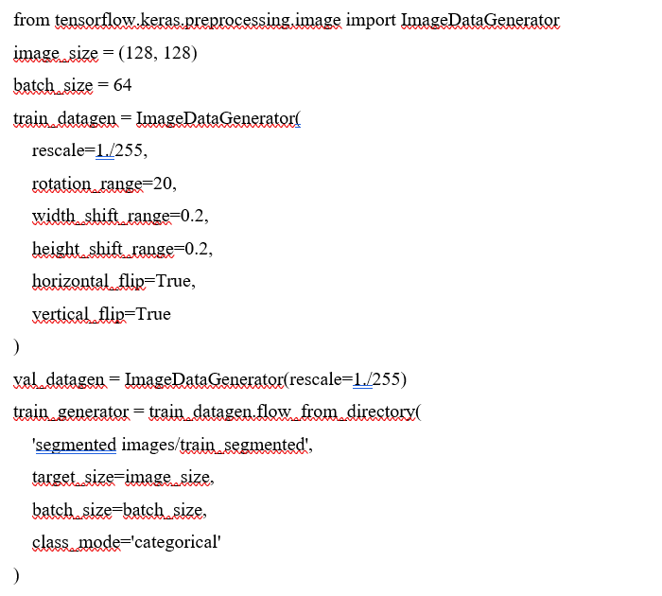

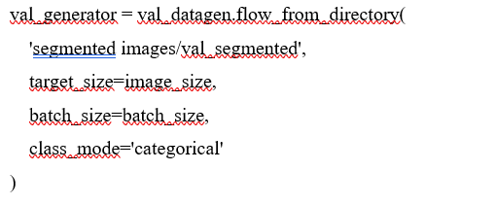

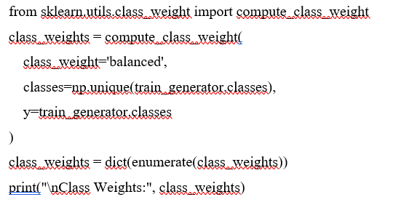

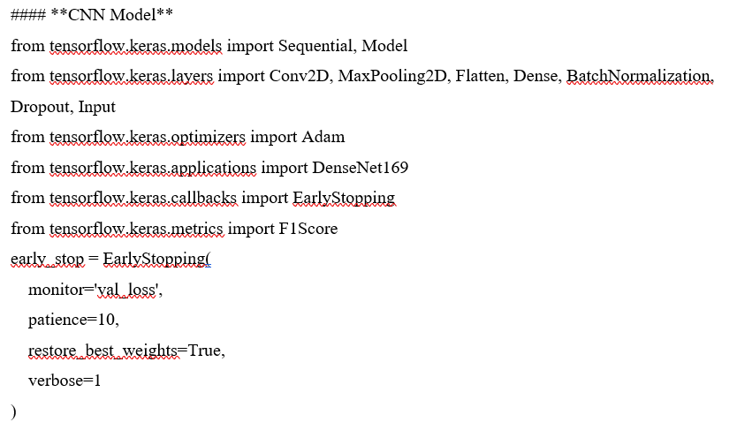
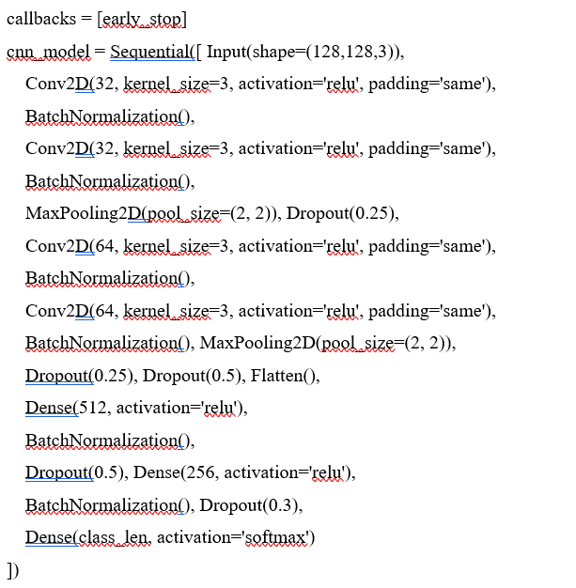
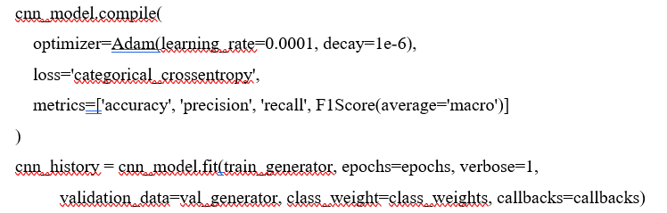

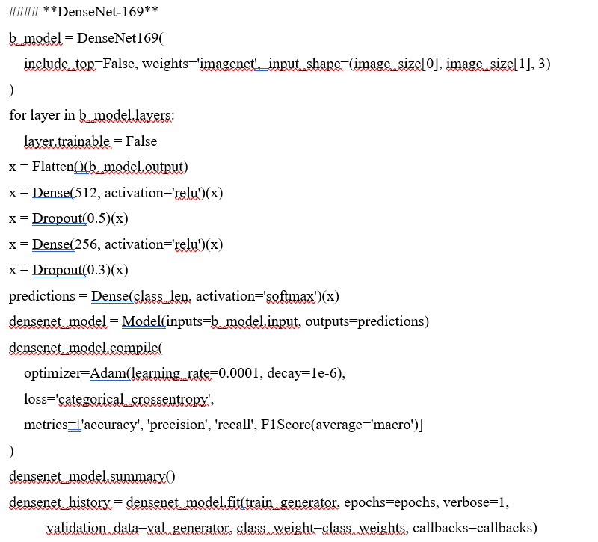

#### Vision Transformers
